Chapter 01
An Introduction to Accounting

Short Answer Questions
1. | Indicate how each event affects the elements of financial statements. Use the following letters to record your answer in the box shown below each element. You do not need to enter amounts.  Ferguson Co. issued common stock for $50,000 cash.

2. | Indicate how each event affects the elements of financial statements. Use the following letters to record your answer in the box shown below each element. You do not need to enter amounts.  Rodriguez Co. borrowed $20,000 cash from Century Bank.

3. | Indicate how each event affects the elements of financial statements. Use the following letters to record your answer in the box shown below each element. You do not need to enter amounts.  Vincent Co. provided services for $25,000 cash.  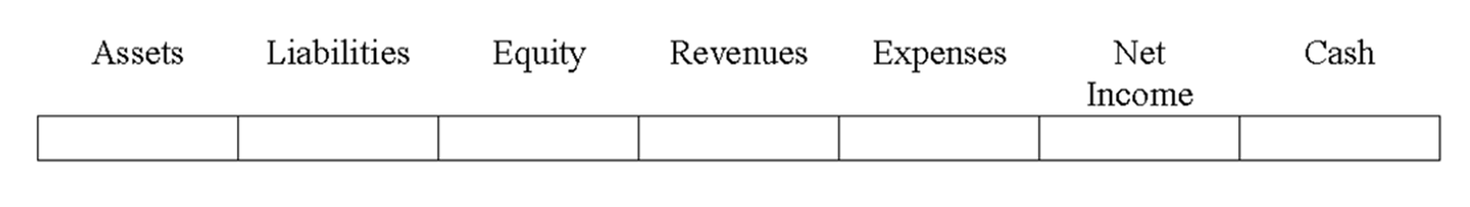

4. | Indicate how each event affects the elements of financial statements. Use the following letters to record your answer in the box shown below each element. You do not need to enter amounts.  Patterson Co. paid $50,000 cash to purchase land.

5. | Indicate how each event affects the elements of financial statements. Use the following letters to record your answer in the box shown below each element. You do not need to enter amounts.  Greene Co. paid $211,000 cash in salaries to its employees.

6. | Indicate how each event affects the elements of financial statements. Use the following letters to record your answer in the box shown below each element. You do not need to enter amounts.  Walsh Co. paid a $50,000 cash dividend to its owners.

7. | Indicate how each event affects the elements of financial statements. Use the following letters to record your answer in the box shown below each element. You do not need to enter amounts.  Vegas Co. issued a note to purchase a building.

8. | Name the group that has the primary authority for establishing U.S. GAAP.

9. | Who are the three distinct types of participants in a market? Briefly describe the role of each group of participants.

10. | What is meant by the term "stakeholders?"

11. | What is meant by the term "global GAAP"? How does it impact U.S. companies? What body is responsible for setting global standards?

12. | Briefly distinguish between financial accounting and managerial accounting.

13. | Explain some of the accounting similarities and differences between not-for-profit organizations and for-profit businesses.

14. | What financial statement elements are reported on a balance sheet?

15. | From what three sources does a business obtain its assets?

16. | How does providing services for cash affect the accounting equation? Is it considered an asset source, asset use, or asset exchange transaction?

17. | How does the payment of cash dividends to stockholders affect the accounting equation? Is it considered an asset source, asset use, or asset exchange transaction?

18. | If the total equity claimed by owners of Ping Construction is $50,000 and liabilities are $25,000, what are total assets?

19. | What is meant by the term double-entry bookkeeping?

20. | Give three examples of asset use transactions.

21. | What does a company's statement of cash flow tell you about the company?

22. | If a corporation issues common stock for $20,000 cash, in which section of the statement of cash flows would this transaction be reported?

23. | Which types of accounts are closed out to retained earnings at the end of an accounting period?

24. | Name and briefly describe each of the four financial statements.

25. | Define the term "accounting period." How does this term relate to the "matching concept" as it pertains to the income statement?

Multiple Choice Questions
26. | Which of the following groups has the primary responsibility for establishing generally accepted accounting principles for business entities in the United States?  A. Internal Revenue Service.  B. U.S. Congress.  C. Financial Accounting Standards Board.  D. International Accounting Standards Board.

27. | The Jefferson Company is a manufacturer of antique reproduction furniture. Which term best describes Jefferson's role in society?  A. Consumer  B. Regulatory Agency  C. Conversion Agent  D. Resource Owner

28. | Which resource provider typically receives first priority when resources are divided as part of a business's liquidation?  A. The company's managers  B. Stockholders  C. Creditors  D. Owners

29. | Which type of accounting information is intended to satisfy the needs of external users of accounting information?  A. Cost accounting  B. Financial accounting  C. Tax accounting  D. Managerial accounting

30. | Managerial accounting provides information primarily to which of the following groups or individuals?  A. Internal users  B. Shareholders  C. External users  D. Internal users and Shareholders

31. | "GAAP" stands for  A. Government Authorized Accounting Procedures.  B. Generally Applied Accounting Procedures.  C. Generally Accepted Accounting Principles.  D. Generally Authorized Auditing Principles.

32. | "IASB" stands for  A. Internal Accounting Standards Board.  B. Internationally Authorized Statements Board.  C. International Accounting Standards Board.  D. Initial Accounting Statements Bureau.

33. | Which of the following items is an example of revenue?  A. Cash received from a bank loan  B. Cash received from customers at the time services were provided  C. Cash investments made by owners  D. All of these

34. | Which of the following is not an element of the financial statements?  A. Cash  B. Revenue  C. Assets  D. Distributions

35. | The balance sheet of the Chesapeake Company contained the following accounts and balances:  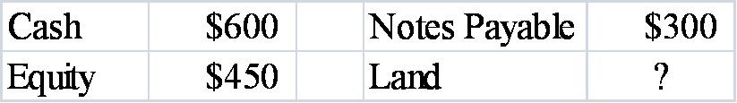  Based on the above information only, the amount or balance for Land must be  A. $450.  B. $750.  C. $150.  D. $1,350.

36. | Vandever Company's balance sheet reported assets of $42,000, liabilities of $15,000 and common stock of $12,000 as of December 31, 2012. If Retained Earnings on the December 31, 2013 balance sheet is $18,000 and Vandever paid a $14,000 dividend during 2013, then the amount of net income for 2013 was which of the following?  A. $17,000  B. $15,000  C. $3,000  D. None of these

37. | Hacienda Company issued common stock for $250,000 cash. As a result of this event,  A. assets increased.  B. retained earnings increased.  C. equity increased.  D. assets increased and equity increased.

38. | If Boyd Company reported assets of $500 and liabilities of $200, Boyd's total claims totaled  A. $300.  B. $500.  C. $700.  D. none of these.

39. | If a company's total assets decreased while liabilities and common stock were unchanged, and no dividends were paid, then  A. cash flow from operating activities was greater than cash flow from investing activities.  B. retained earnings were less than net income during the period.  C. revenues were less than expenses.  D. the company must have purchased assets with cash.

40. | Varghese Company paid cash to purchase land. As a result of this accounting event  A. total assets decreased.  B. total assets were unaffected.  C. total equity decreased.  D. none of these.

41. | The total equity of Timberlake Company at the beginning of 2013 amounted to $5,500. During 2013 the company reported net income of $1,800 and paid a $500 dividend. If retained earnings at the end of 2013 is $2,200, what was beginning common stock?  A. $3,300  B. $2,800  C. $1,300  D. $4,600

42. | A company mistakenly recorded a cash purchase of land as an expense. As a result of this error  A. Assets were understated and equity was overstated.  B. Assets and equity were understated.  C. Assets and equity were overstated.  D. Assets were overstated and equity was understated.

43. | As of December 31, 2013, Bloch Company had $3,800 of assets, $1,600 of liabilities and $700 of retained earnings. The balance in the common stock account on the December 31, 2013 balance sheet was  A. $2,900.  B. $3,800.  C. $1,500.  D. none of these.

44. | On January 1, 2013, Baird Company had beginning balances as lows:  Assets = $2,250  Liabilities = $620  Common Stock = $800  During 2013, Baird paid dividends to its stockholders of $900. Given that ending retained earnings was $600, what was Baird's net income for the 2013 accounting period?  A. $770  B. $830  C. $1,250  D. $500

45. | The transaction, "earned cash revenue," affects which two accounts?  A. Revenue and Salaries Expense  B. Cash and Notes Payable  C. Cash and Revenue  D. Cash and Dividends

46. | During 2013, Bledsoe Company earned $6,700 of cash revenue, paid cash dividends of $950 to owners and paid $5,000 for cash expenses. Liabilities were unchanged. Which of the following accurately describes the effect of these events on the elements of the company's financial statements?  A. Assets increased by $7,700.  B. Assets increased by $750.  C. Equity increased by $2,700.  D. Assets increased by $750 and Equity increased by $2,700.

47. | At the end of 2013, retained earnings for the Bisk Company was $1,750. Revenue earned by the company in 2013 was $2,000, expenses paid during the period were $1,100, and dividends paid during the period were $500. Based on this information alone, retained earnings at the beginning of 2013 was  A. $850.  B. $2,150.  C. $1,350.  D. $4,000.

48. | Which of the following is NOT an asset use transaction?  A. Paying cash to purchase land  B. Paying cash expenses  C. Paying off the principal of a loan  D. All of these are asset use transactions

49. | Borrowing cash from the bank is an example of which type of transaction?  A. Asset exchange  B. Claims use  C. Asset use  D. Asset source

50. | Which of the following could describe the effects of an asset exchange transaction on a company's financial statements?  A.  B.  C.  D.

51. | Which of the following describes the effects of an asset use transaction on a company's financial statements?  A.  B.  C.  D.

52. | Which of the following statements regarding cash transactions is true?  A. Purchasing land for cash results in no net change in assets.  B. Issuance of stock to owners increases assets.  C. Expense transactions increase assets.  D. Purchasing land for cash results in no net change in assets and Issuance of stock to owners increases assets.

53. | Which of the following items appears in the investing activities section of the statement of cash flows?  A. Cash outflow for the purchase of a computer.  B. Cash inflow from the issuance of common stock.  C. Cash outflow for the payment of dividends.  D. Cash inflow from interest revenue.

54. | Jacks Company had a net increase in cash from operating activities of $8,000 and a net decrease in cash from financing activities of $1,000. If the beginning and ending cash balances for the company were $3,000 and $11,000, then net cash change from investing activities was:  A. an outflow or decrease of $1,000.  B. an inflow or increase of $2,000.  C. an inflow or increase of $1,000.  D. zero.

55. | The year-end financial statements of Greenway Company contained the following elements and corresponding amounts: Assets = $20,000; Liabilities = ?; Common Stock = $5,000; Revenue = $11,000; Dividends = $750; Beginning Retained Earnings = $3,750; Ending Retained Earnings = $7,000.  Based on this information, the amount of expenses on Greenway's income statement was  A. $7,000.  B. $7,750.  C. $14,000.  D. $3,250.

56. | The year-end financial statements of Greenway Company contained the following elements and corresponding amounts: Assets = $20,000; Liabilities = ?; Common Stock = $5,000; Revenue = $11,000; Dividends = $750; Beginning Retained Earnings = $3,750; Ending Retained Earnings = $7,000.  The amount of liabilities reported on the end-of-period balance sheet was  A. $10,750.  B. $11,250.  C. $8,000.  D. $8,750.

57. | Which of the following financial statements provides information about a company as of a specific point in time?  A. Income statement  B. Statement of changes in equity  C. Statement of cash flows  D. Balance sheet

58. | Which of the following statements is true?  A. Balance sheet accounts are referred to as nominal accounts.  B. Balance sheet accounts are referred to as permanent accounts.  C. Dividends are permanent accounts.  D. All of these statements are true.

59. | In which section of a statement of cash flows would the payment of cash dividends be reported?  A. Financing activities.  B. Operating activities.  C. Purchasing activities.  D. Investing activities.

60. | Which financial statement matches asset increases from operating a business with asset decreases from operating the business?  A. Balance sheet.  B. Statement of changes in equity.  C. Statement of cash flows.  D. Income statement.

61. | Callahan Company earned $1,500 of cash revenue, paid $1,000 for cash expenses, and paid a $200 cash dividend to its owners. Which of the following statements is true?  A. The net cash flow from operating activities was $500.  B. The net cash flow from investing activities was an outflow or decrease of $200.  C. The net cash flow from operating activities was $300.  D. Cash flows from financing activities were unchanged.

62. | Young Company provided services to a customer for $6,500 cash. As a result of this event,  A. total assets decreased.  B. total liabilities increased.  C. net income increased.  D. cash flow from financing activities increased.

63. | During 2013, Chi Company earned $950 of cash revenue, paid $600 of cash expenses, and paid a $100 cash dividend to its owners. Based on this information alone,  A. net income amounted to $350.  B. total assets increased by $250.  C. cash inflow from operating activities was $350.  D. all of these are correct.

64. | Grant Company purchased a delivery van for cash. The cash flow from this event should be shown on the statement of cash flows as  A. an operating activity that increases cash.  B. a financing activity that decreases cash.  C. an investing activity that decreases cash.  D. an operating activity that decreases cash.

65. | Retained Earnings at the beginning and ending of the accounting period was $300 and $700, respectively. If revenues were $1,100 and dividends paid to stockholders were $200, expenses for the period must have been  A. $500.  B. $400.  C. $900.  D. $700.

66. | Yi Company began operations on January 1, 2013. During 2013, the company engaged in the following cash transactions:  1) issued stock for $40,000  2) borrowed $25,000 from its bank  3) provided consulting services for $38,000  4) paid back $15,000 of the bank loan  5) paid rent expense for $9,000  6) purchased equipment costing $12,000  7) paid $3,000 dividends to stockholders  8) paid employees' salaries, $21,000  What is Yi's net cash flow from operating activities?  A. Inflow of $5,000  B. Inflow of $8,000  C. Inflow of $17,000  D. Inflow of $33,000

67. | Yi Company began operations on January 1, 2013. During 2013, the company engaged in the following cash transactions:  1) issued stock for $40,000  2) borrowed $25,000 from its bank  3) provided consulting services for $38,000  4) paid back $15,000 of the bank loan  5) paid rent expense for $9,000  6) purchased equipment costing $12,000  7) paid $3,000 dividends to stockholders  8) paid employees' salaries, $21,000  What is Yi's net cash flow from investing activities?  A. Inflow of $40,000  B. Outflow of $37,000  C. Inflow of $28,000  D. Outflow of $12,000

68. | Yi Company began operations on January 1, 2013. During 2013, the company engaged in the following cash transactions:  1) issued stock for $40,000  2) borrowed $25,000 from its bank  3) provided consulting services for $38,000  4) paid back $15,000 of the bank loan  5) paid rent expense for $9,000  6) purchased equipment costing $12,000  7) paid $3,000 dividends to stockholders  8) paid employees' salaries, $21,000  What is Yi's cash flow from financing activities?  A. Inflow of $37,000  B. Outflow of $15,000  C. Inflow of $47,000  D. Outflow of $3,000

69. | Petras Company engaged in the following transactions during 2012, its first year in operations: (Assume all transactions are cash transactions)  1) Acquired $950 cash from the issue of common stock.  2) Borrowed $420 from a bank.  3) Earned $600 of revenues.  4) Paid expenses of $250.  5) Paid a $50 dividend.  During 2013, Petras engaged in the following transactions: (Assume all transactions are cash transactions)  1) Issued an additional $325 of common stock.  2) Repaid $220 of its debt to the bank.  3) Earned revenues of $750.  4) Incurred expenses of $360.  5) Paid dividends of $100.  Petras Company's net cash inflow from operating activities for 2012 is  A. $600.  B. $550.  C. $350.  D. $300.

70. | Petras Company engaged in the following transactions during 2012, its first year in operations: (Assume all transactions are cash transactions)  1) Acquired $950 cash from the issue of common stock.  2) Borrowed $420 from a bank.  3) Earned $600 of revenues.  4) Paid expenses of $250.  5) Paid a $50 dividend.  During 2013, Petras engaged in the following transactions: (Assume all transactions are cash transactions)  1) Issued an additional $325 of common stock.  2) Repaid $220 of its debt to the bank.  3) Earned revenues of $750.  4) Incurred expenses of $360.  5) Paid dividends of $100.  The total in Petras' retained earnings account BEFORE closing in 2012 is  A. $0.  B. $300.  C. $350.  D. none of these.

71. | Petras Company engaged in the following transactions during 2012, its first year in operations: (Assume all transactions are cash transactions)  1) Acquired $950 cash from the issue of common stock.  2) Borrowed $420 from a bank.  3) Earned $600 of revenues.  4) Paid expenses of $250.  5) Paid a $50 dividend.  During 2013, Petras engaged in the following transactions: (Assume all transactions are cash transactions)  1) Issued an additional $325 of common stock.  2) Repaid $220 of its debt to the bank.  3) Earned revenues of $750.  4) Incurred expenses of $360.  5) Paid dividends of $100.  The amount of total equity on Petras' 2012 balance sheet is  A. $1,250.  B. $900.  C. $300.  D. $1,300.

72. | Petras Company engaged in the following transactions during 2012, its first year in operations: (Assume all transactions are cash transactions)  1) Acquired $950 cash from the issue of common stock.  2) Borrowed $420 from a bank.  3) Earned $600 of revenues.  4) Paid expenses of $250.  5) Paid a $50 dividend.  During 2013, Petras engaged in the following transactions: (Assume all transactions are cash transactions)  1) Issued an additional $325 of common stock.  2) Repaid $220 of its debt to the bank.  3) Earned revenues of $750.  4) Incurred expenses of $360.  5) Paid dividends of $100.  The amount of retained earnings on Petras's 2013 balance sheet is  A. $915.  B. $890.  C. $590.  D. $690.

73. | Petras Company engaged in the following transactions during 2012, its first year in operations: (Assume all transactions are cash transactions)  1) Acquired $950 cash from the issue of common stock.  2) Borrowed $420 from a bank.  3) Earned $600 of revenues.  4) Paid expenses of $250.  5) Paid a $50 dividend.  During 2013, Petras engaged in the following transactions: (Assume all transactions are cash transactions)  1) Issued an additional $325 of common stock.  2) Repaid $220 of its debt to the bank.  3) Earned revenues of $750.  4) Incurred expenses of $360.  5) Paid dividends of $100.  The amount of assets on Petras's 2013 balance sheet is  A. $2,165.  B. $390.  C. $2,065.  D. $395.

74. | Petras Company engaged in the following transactions during 2012, its first year in operations: (Assume all transactions are cash transactions)  1) Acquired $950 cash from the issue of common stock.  2) Borrowed $420 from a bank.  3) Earned $600 of revenues.  4) Paid expenses of $250.  5) Paid a $50 dividend.  During 2013, Petras engaged in the following transactions: (Assume all transactions are cash transactions)  1) Issued an additional $325 of common stock.  2) Repaid $220 of its debt to the bank.  3) Earned revenues of $750.  4) Incurred expenses of $360.  5) Paid dividends of $100.  The net cash inflow from financing activities on Petras's 2013 statement of cash flows is  A. $5.  B. $325.  C. $225.  D. $955.

75. | Which of the following items would appear in the cash flow from the financing activities section of a statement of cash flows?  A. Paid cash for expenses.  B. loaned cash to another company.  C. Sold land for cash.  D. Paid cash for dividends.

76. | George Company was started on January 1, 2013, when it acquired $8,000 cash by issuing common stock. During 2013, the company earned cash revenues of $3,500, paid cash expenses of $2,750, and paid a cash dividend of $300. Based on this information,  A. The December 31, 2013 balance sheet would show total equity of $11,500.  B. The 2013 income statement would show net income of $450.  C. The 2013 statement of cash flows would show net cash inflow from operating activities of $750.  D. The 2013 statement of cash flows would show a net cash flow from financing activities of $8,000.

77. | Richardson Company paid $850 cash for rent expense. As a result of this business event,  A. Total assets decreased.  B. Liabilities decreased.  C. The net cash flow from operating activities decreased.  D. Total assets decreased and the net cash flow from operating activities decreased are correct.

78. | Mineola Company paid $30,000 cash to purchase land. As a result of this business event,  A. Total equity was not affected.  B. The net cash flow from investing activities decreased.  C. Total assets were not affected.  D. All of these are correct.

79. | La Paz Company engaged in the following transactions during 2012, its first year in operation: (Assume all transactions are cash transactions)  1. Acquired $3,000 cash from issuing common stock.  2. Borrowed $2,200 from a bank.  3. Earned $3,100 of revenues.  4. Incurred $2,400 in expenses.  5. Paid dividends of $400.  La Paz Company engaged in the following transactions during 2013:  1. Acquired an additional $500 cash from the issue of common stock.  2. Repaid $1,300 of its debt to the bank.  3. Earned revenues, $4,500.  4. Incurred expenses of $2,750.  5. Paid dividends of $640.  The net cash flow from financing activities on La Paz's 2013 statement of cash flows was  A. $1,440 inflow.  B. $1,440 outflow.  C. $500 inflow.  D. $140 outflow.

80. | La Paz Company engaged in the following transactions during 2012, its first year in operation: (Assume all transactions are cash transactions)  1. Acquired $3,000 cash from issuing common stock.  2. Borrowed $2,200 from a bank.  3. Earned $3,100 of revenues.  4. Incurred $2,400 in expenses.  5. Paid dividends of $400.  La Paz Company engaged in the following transactions during 2013:  1. Acquired an additional $500 cash from the issue of common stock.  2. Repaid $1,300 of its debt to the bank.  3. Earned revenues, $4,500.  4. Incurred expenses of $2,750.  5. Paid dividends of $640.  The amount of total assets on La Paz's 2012 balance sheet was  A. $6,000.  B. $5,500.  C. $800.  D. $3,800.

81. | La Paz Company engaged in the following transactions during 2012, its first year in operation: (Assume all transactions are cash transactions)  1. Acquired $3,000 cash from issuing common stock.  2. Borrowed $2,200 from a bank.  3. Earned $3,100 of revenues.  4. Incurred $2,400 in expenses.  5. Paid dividends of $400.  La Paz Company engaged in the following transactions during 2013:  1. Acquired an additional $500 cash from the issue of common stock.  2. Repaid $1,300 of its debt to the bank.  3. Earned revenues, $4,500.  4. Incurred expenses of $2,750.  5. Paid dividends of $640.  The amount of retained earnings on La Paz's 2012 balance sheet was  A. $3,100.  B. $2,700.  C. $300.  D. $700.

82. | La Paz Company engaged in the following transactions during 2012, its first year in operation: (Assume all transactions are cash transactions)  1. Acquired $3,000 cash from issuing common stock.  2. Borrowed $2,200 from a bank.  3. Earned $3,100 of revenues.  4. Incurred $2,400 in expenses.  5. Paid dividends of $400.  La Paz Company engaged in the following transactions during 2013:  1. Acquired an additional $500 cash from the issue of common stock.  2. Repaid $1,300 of its debt to the bank.  3. Earned revenues, $4,500.  4. Incurred expenses of $2,750.  5. Paid dividends of $640.  The amount of liabilities on La Paz's 2013 balance sheet was  A. $900.  B. $500.  C. ($1,300).  D. $240.

83. | As of December 31, 2012, Montross Company had $400 cash. During 2013, Montross earned $1,200 of cash revenue and paid $800 of cash expenses. The amount of cash shown on the 2013 balance sheet would be  A. $300.  B. $800.  C. $1,100.  D. $2,400.

84. | Expenses are shown on the  A. balance sheet.  B. income statement.  C. statement of changes in stockholders' equity.  D. income statement and statement of changes in stockholders' equity.

85. | Dividends paid by a company are shown on the  A. income statement.  B. statement of changes in stockholders' equity.  C. statement of cash flows.  D. statement of changes in stockholders' equity and statement of cash flows.

86. | Liabilities are shown on the  A. income statement.  B. balance sheet.  C. statement of cash flows.  D. statement of changes in stockholders' equity.

87. | Falcon Company earned $15,000 of cash revenue. Which of the following choices accurately reflects how this event affects the company's financial statements?  A.  B.  C.  D.

88. | Freed Company paid $500 cash for salary expenses. Which of the following choices accurately reflects how this event affects the company's financial statements?  A.  B.  C.  D.

89. | Jiminez Company paid a $300 cash dividend. Which of the following choices accurately reflects how this event affects the company's financial statements?  A.  B.  C.  D.

90. | Tandem Company acquired $23,000 by issuing common stock. Which of the following choices accurately reflects how this event affects the company's financial statements?  A.  B.  C.  D.

91. | Treadwell Company borrowed $32,000 of cash from a local bank. Which of the following choices accurately reflects how this event affects the company's financial statements?  A.  B.  C.  D.

92. | Burton Company sold land for $25,000 cash. The original cost of the land was $25,000. Select the answer that indicates how this event affects the company's financial statements.  A.  B.  C.  D.

93. | Which of the following could represent the effects of an asset source transaction on a company's financial statements?  A.  B.  C.  D.

94. | Which of the following could represent the effects of an asset exchange transaction on a company's financial statements?  A.  B.  C.  D.

95. | Which of the following represents effects of an asset use transaction on a company's financial statements?  A.  B.  C.  D.

96. | Rialto Company experienced an accounting event that affected its financial statements as indicated below:  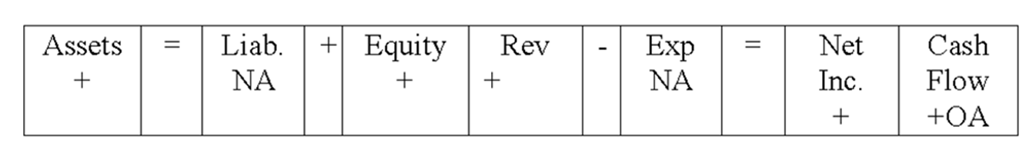  Which of the following accounting events could have caused these effects on Rialto's statements?  A. Paid a cash dividend.  B. Earned cash revenue.  C. Borrowed money from a bank.  D. None of these.

97. | Cohen Company experienced an accounting event that affected its financial statements as indicated below:  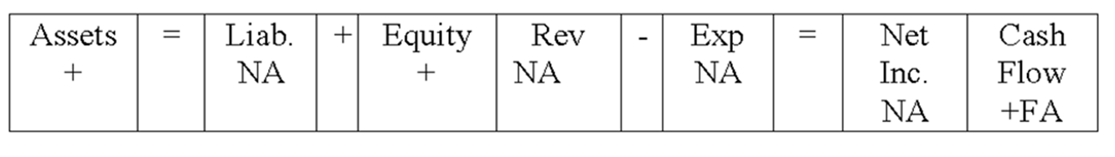  Which of the following accounting events could have caused these effects on Cohen's statements?  A. Paid a cash dividend.  B. Earned cash revenue.  C. Borrowed money from a bank.  D. Issued common stock.

98. | Dover Company experienced an accounting event that affected its financial statements as indicated below:  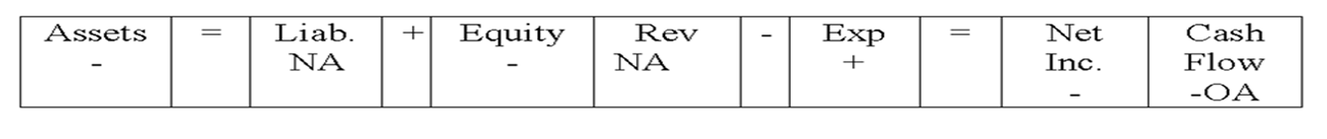  Which of the following accounting events could have caused these effects on Dover's statements?  A. Paid a cash dividend.  B. Earned cash revenue.  C. Borrowed money from a bank.  D. Incurred a cash expense.

99. | Vantage Corporation invested $800 cash in Tandem Company stock.  Which of the following describes the effects of this transaction on Vantage Corporation's books?  A.  B.  C.  D.

100. | Vantage Corporation invested $800 cash in Tandem Company stock.  As a result of this transaction,  A. Vantage Corporation would have a cash outflow from financing activities.  B. Tandem Company would have a cash inflow from investing activities.  C. The balance in the Cash account on Vantage's books would decrease, while the balance in the Cash account on Tandem Company's books would increase.  D. All of these statements are true.

101. | Vantage Corporation invested $800 cash in Tandem Company stock.  Which of the following could describe the effects of an asset source transaction on a company's financial statements?  A.  B.  C.  D.

Essay Questions
102. | Indicate whether each of the following statements about markets is true or false.  _______ a) Financial resources can be provided to a business by investors and creditors.  _______ b) Conversion agents are the businesses that transform resources into products that satisfy consumer desires.  _______ c) Physical resources include the labor of the production workers.  _______ d) Resource owners purchase their resources from conversion agents.  _______ e) Consumers are the main providers of resources in any market.

103. | Indicate whether each of the following statements about accounting information is true or false.  _______ a) Financial accounting is primarily intended to satisfy the information needs of external resource providers.  _______ b) Financial accounting information is useful only to banks and stockholders.  _______ c) The accounting information intended to satisfy the needs of a company's employees is managerial accounting information.  _______ d) GAAP requires that companies adhere to managerial accounting standards.  _______ e) Managerial accounting information is usually more detailed than financial accounting information.

104. | Indicate whether each of the following statements about liabilities is true or false.  _______ a) A net loss on the income statement decreases liabilities.  _______ b) The acquisition of a bank loan increases both assets and liabilities.  _______ c) The accounting equation requires that liabilities be equal to equity.  _______ d) The amount of a company's liabilities is equal to (assets - equity).  _______ e) Liabilities are reported on the statement of cash flows of a business.

105. | Indicate whether each of the following statements about retained earnings is true or false.  _______ a) A dividend paid to stockholders decreases retained earnings.  _______ b) Issuing common stock for cash increases retained earnings.  _______ c) The amount of net income for a period must equal retained earnings.  _______ d) The purchase of a truck decreases retained earnings.  _______ e) The amount of net income for a period increases retained earnings.

106. | Indicate whether each of the following statements about the types of transactions is true or false.  _______ a) An asset source transaction increases total assets and decreases claims to assets.  _______ b) The issuance of stock to owners for cash would be an example of an asset exchange transaction.  _______ c) Purchasing equipment for cash is an example of an asset exchange transaction.  _______ d) Paying a dividend to stockholders is an example of an asset use transaction.  _______ e) Making a payment on a bank loan is an example of an asset exchange transaction.

107. | Indicate whether each of the following statements about financial statements is true or false.  _______ a) A cash dividend paid to stockholders is shown on the statement of cash flows.  _______ b) A cash dividend paid to stockholders is shown on the statement of changes in stockholders' equity.  _______ c) A cash dividend paid to stockholders is shown on the income statement.  _______ d) Among other things, the balance sheet shows how a company got its cash.  _______ e) Changes in retained earnings for the accounting period are shown on the income statement.

108. | Indicate whether each of the following statements about equity is true or false.  _______ a) Operating expenses reported on the income statement increase retained earnings.  _______ b) Common Stock is a part of contributed or paid-in capital for a corporation.  _______ c) Retained earnings is increased by loans received from a bank.  _______ d) Dividends paid to stockholders decrease retained earnings.  _______ e) Owners' equity is the residual interest in the company resulting from the difference between assets and liabilities.

True / False Questions
109. | In a market, consumers are resource providers.  True False

110. | In a market, a company that manufactures cars would be referred to as a conversion agent.  True False

111. | The value created by a business may be called income or earnings.  True False

112. | A business's creditors have a priority claim to its assets in the event of liquidation.  True False

113. | The types of resources needed by a business are financial, physical, and capital resources.  True False

114. | Financial accounting information is usually more detailed than managerial accounting information.  True False

115. | The Financial Accounting Standards Board is an agency of the US government with authority for establishing accounting standards for businesses in the US.  True False

116. | A business and the person who owns the business are separate reporting entities.  True False

117. | Accounts are subclassifications of the various elements of the financial statements.  True False

118. | Equity represents the future obligations of a business entity.  True False

119. | Both liabilities and equity are sources of a business's assets.  True False

120. | Retained earnings reduces a company's commitment to use its assets for the benefit of its stockholders.  True False

121. | The accounting term "reliability" refers to information that is consistent from one accounting period to the next.  True False

122. | An asset source transaction increases a business's assets and the claims to assets.  True False

123. | Borrowing money from the bank is an example of an asset source transaction.  True False

124. | An asset exchange transaction does not affect the total amount of claims to a company's assets.  True False

125. | The four financial statements prepared by a business bear no relationship to each other.  True False

126. | A business's temporary accounts include revenues, expenses, and retained earnings.  True False

Essay Questions
127. | Stinespring Company was founded in 2012. It acquired $35,000 cash by issuing stock to investors and an additional $20,000 cash by borrowing from creditors. During 2012 it received $15,000 cash revenues and paid $22,000 in cash expenses. The company then went out of business.  Required:  a) Explain the term, "business liquidation."  b) What amount of cash should Stinespring Company have had on hand immediately before going out of business?  c) What amount of cash will Stinespring's creditors receive?  d) What amount of cash will Stinespring's stockholders receive?

128. | The transactions listed below apply to Lovell Company for its first year in business. Assume that all transactions involve the receipt or payment of cash.  Transactions for the year 2012:  1) Issued common stock to investors for $15,000 cash.  2) Borrowed $8,000 from the local bank.  3) Provided services to customers for $18,000.  4) Paid expenses amounting to $11,400.  5) Purchased a plot of land costing $12,000.  6) Paid a dividend of $6,000 to its stockholders.  7) Repaid $4,000 of the loan listed in item 2.  Required:  (a) Fill in the headings to the accounting equation shown below.  (b) Show the effects of the above transactions on the accounting equation.

129. | Each of the following requirements is independent of the others.  a) Viking Corporation has liabilities of $85,000 and equity of $115,000. What is the amount of Viking's assets? _________________________________________________  b) Garibaldi Company has assets of $310,000 and liabilities of $95,000. What is the amount of Garibaldi's equity? ______________________________________________________  c) King Company has assets of $70,000 and liabilities of $25,000. What is the amount of King's claims? _____________________________________________________________

130. | The following events occurred for Jarvis Company during 2012, its first year in operation:  1. issued stock to investors for $35,000 cash  2. borrowed $15,000 cash from the local bank  3. provided services to its customers and received $22,000 cash  4. paid expenses of $18,000  5. paid $12,000 cash for land  6. paid dividend of $2,000 to stockholders  7. repaid $2,000 of the loan listed in item 2  Required:  Show the effects of the above transactions on the accounting equation, below. Include dollar amounts of increases and decreases. The first is done for you. After entering all the events, calculate the total amounts of assets, liabilities, and equity at the end of the year.  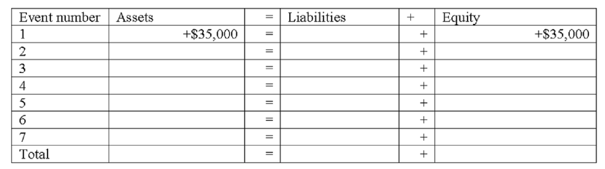

131. | Ramon Company experienced the following events during 2012:  1. Acquired $50,000 cash by issuing common stock  2. Borrowed $15,000 cash from a creditor  3. Provided services to customers for $33,000 cash  4. Paid $27,000 cash for operating expenses  5. Paid a cash dividend of $1,500 to stockholders  6. Purchased land with cash, $25,000  Required:  a) Show how each of these events affects the accounting equation. Show amounts and increases or decreases, using + for increases and - for decreases and NA for no effect. The first event is done as an example.  b) Calculate the total amount of assets, liabilities, common stock, and retained earnings at the end of the period.  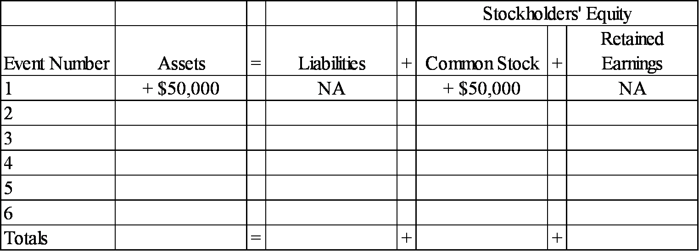

132. | At the beginning of 2012, Gratiot Company's accounting records had the general ledger accounts and balances shown in the table below. During 2012, the following transactions occurred:  1. received $95,000 cash for providing services to customers  2. paid salaries expense, $50,000  3. purchased land for $12,000 cash  4. paid $4,000 on note payable  5. paid operating expenses, $22,000  6. paid cash dividend, $2,500  Required:  a) Record the transactions in the appropriate general ledger accounts. Record the amounts of revenue, expense, and dividends in the retained earnings column. Provide appropriate titles for these accounts in the last column of the table.  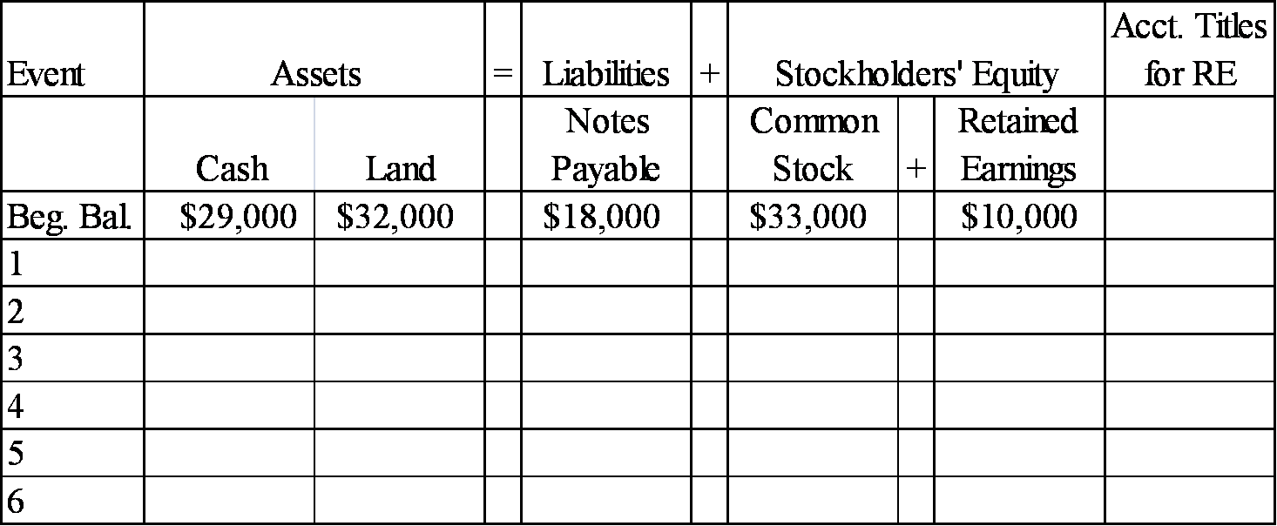  b) What is the amount of total assets as of December 31, 2012?  c) What is the amount of total stockholders' equity as of December 31, 2012?

133. | Jarvis Company experienced the following events during 2012 (all were cash events):  1. issued a note  2. purchased land  3. provided services to customers  4. repaid part of the note in event 1  5. paid operating expenses  6. paid a dividend to stockholders  7. issued common stock  Required:  Indicate how each of these events affects the accounting equation by writing the letter I for increase, the letter D for decrease, and NA for no effect under each of the components of the accounting equation. The first is done for you as an example.  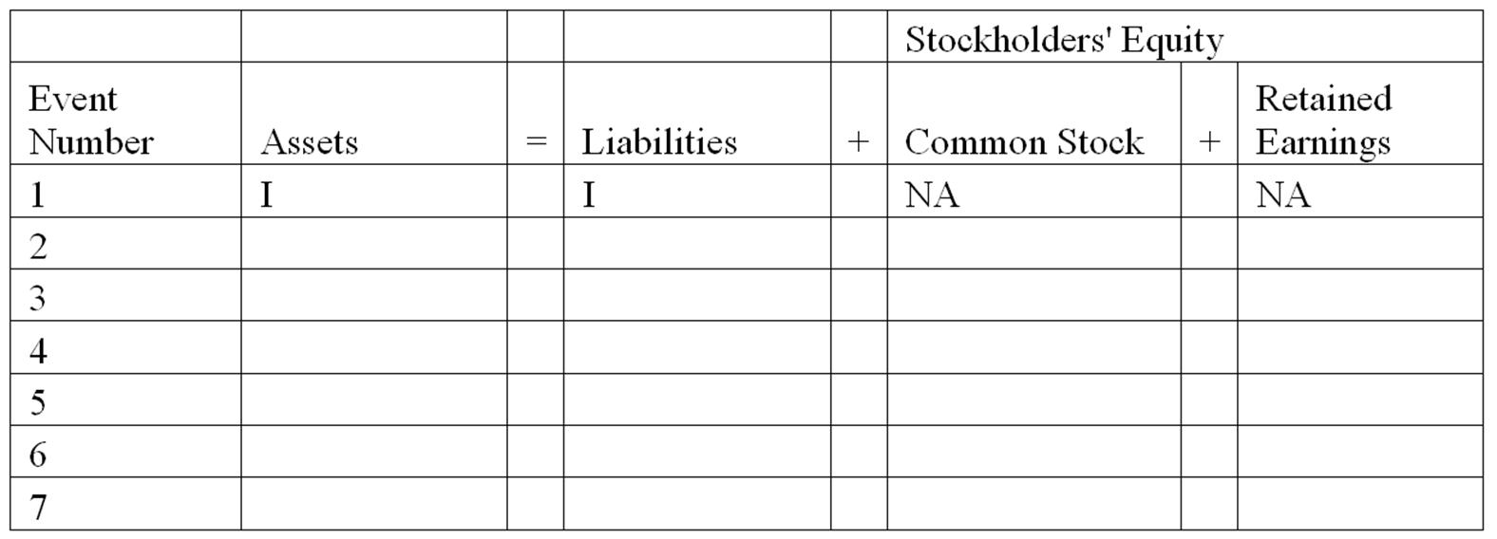

134. | Indicate how each of the following transactions affect assets by entering + for increase, - for decrease, or NA if total assets are not affected.  _______ 1) Issued stock to investors.  _______ 2) Borrowed cash from the bank.  _______ 3) Provided services for cash.  _______ 4) Purchased land for cash.  _______ 5) Paid operating expenses.  _______ 6) Paid cash dividend to the stockholders.  _______ 7) Repaid the bank loan.

135. | Classify each of the following events as an asset source (AS), asset use (AU), asset exchange (AX), or not applicable (NA).  _______ 1) Borrowed cash from the bank.  _______ 2) Issued stock for cash.  _______ 3) Invested cash in the common stock of another company.  _______ 4) Paid cash for operating expense.  _______ 5) Performed services and collected cash.  _______ 6) Purchased equipment for cash.  _______ 7) Repaid the bank loan with cash.  _______ 8) Dividends paid to the stockholders.

136. | Grayson Corporation reports the following cash transactions for the year ending December 31, 2012, its first year of operation:  1) issued common stock for $36,000  2) borrowed $20,000 from a local bank  3) purchased land for $24,000  4) provided services to clients for $28,000  5) paid operating expenses of $21,500  6) paid $2,500 cash dividends to stockholders  Required:  a) What are the total assets for Grayson Corporation at December 31, 2012?  b) Prepare an income statement for 2012.

137. | Yang Company reported the following balance sheet for the end of 2012:  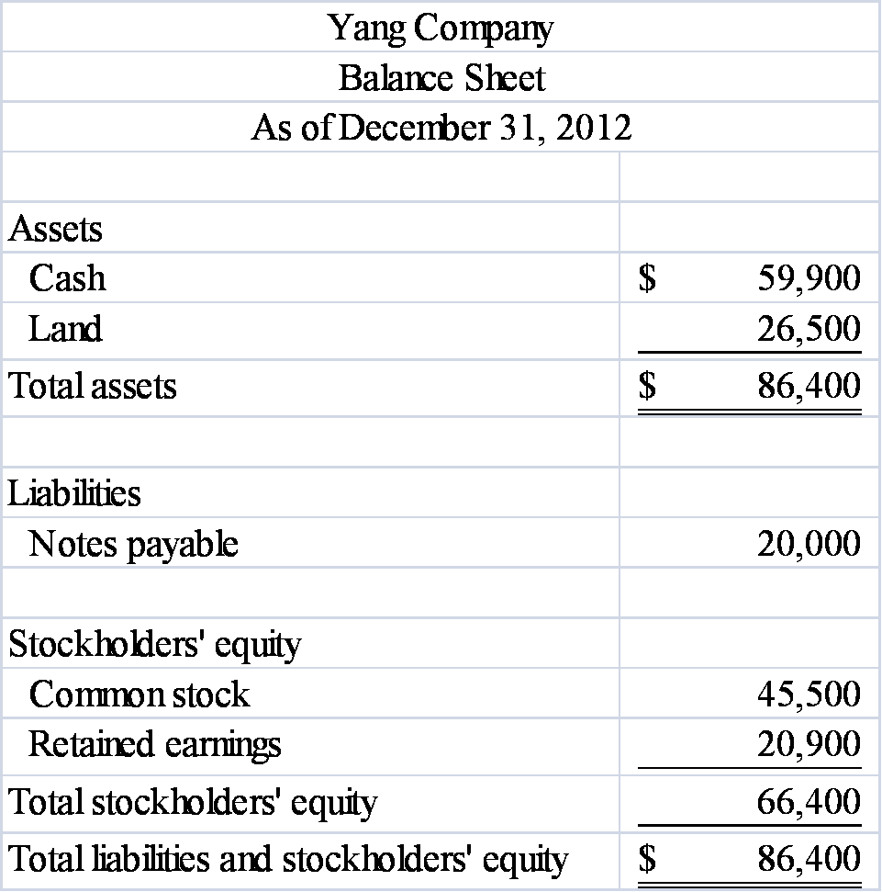  During 2013, Yang reported the following transactions:  • Repaid $8,000 to a local bank on a note payable  • Provided services to clients for $26,400 cash  • Paid operating expenses of $19,200  • Paid $3,500 cash dividends to stockholders  Required:  Prepare Yang Company's balance sheet as of December 31, 2013.

138. | Use the following information to prepare an income statement for Grandin Company for the period ending December 31, 2012. All transactions were for cash.  A) Received revenue from services provided to customers, $28,500.  B) Paid $19,000 cash for land.  C) Paid operating expenses, $19,400.  D) Paid dividends to stockholders, $3,200.  E) Issued $16,000 of common stock.

139. | The following events are for Leisure Travel Services for the year 2013, the first year of operations. Assume that all transactions involve the receipt or payment of cash.  1) The business acquired $40,000 from stock issued to owners.  2) Creditors loaned the company $17,500.  3) The company provided services to its customers and received $55,400.  4) The company paid expenses amounting to $43,250.  5) The company purchased land for $29,000.  6) The company paid a dividend of $5,000 to its owners.  Required:  a) Show the effects of the above transactions on the accounting equation (use appropriate element and account headings). For those events that affect retained earnings, indicate in a separate column the appropriate temporary account.  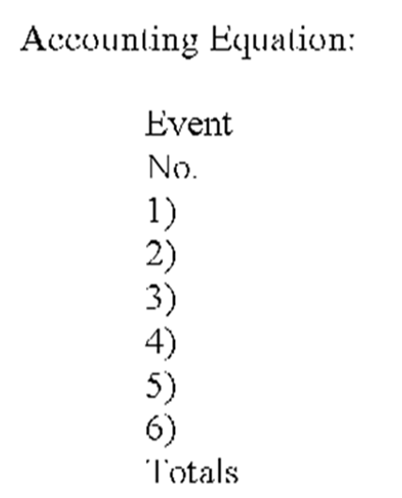  b) Prepare an income statement and balance sheet for the year 2013.

140. | The following transactions apply to Warren Fitness Center for 2012.  1) Started the business by issuing $38,000 of common stock for cash.  2) Provided services to clients and received $28,500 cash.  3) Borrowed $7,500 from the bank.  4) Paid $6,500 for rent of equipment.  5) Purchased land for $12,000.  6) Paid $16,600 of salary expense.  7) Cash dividends of $4,500 were paid to the stockholders.  Required:  a) What are the total assets of the business at the end of 2012?  b) Prepare a Statement of Cash Flows for 2012.

141. | Fill in the missing information by determining the amounts represented by letters a - d.  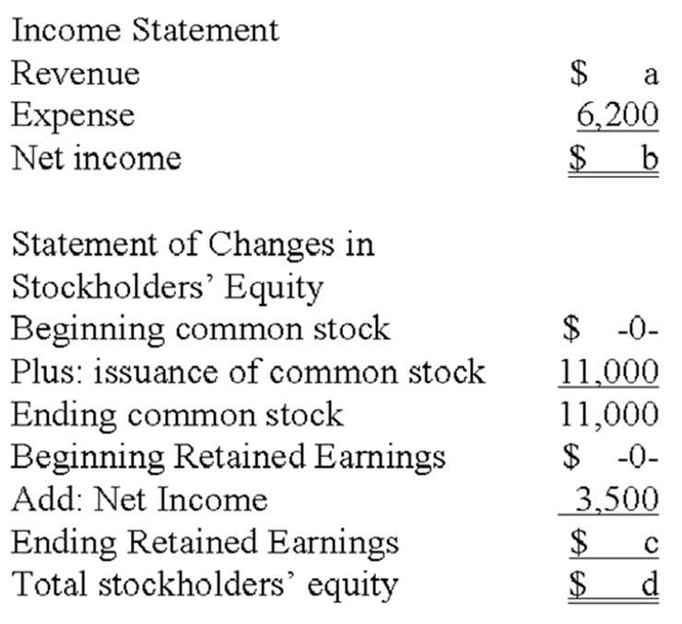

142. | Fill in the blanks indicated by the alphabetic letters in the following financial statements. These financial statements were prepared for the company's first year in operation, and all transactions were for cash.  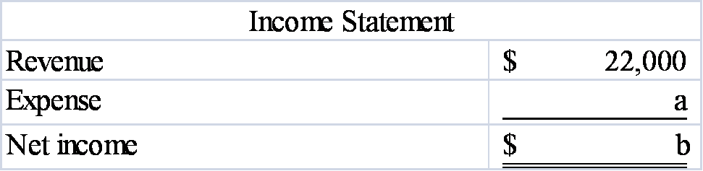  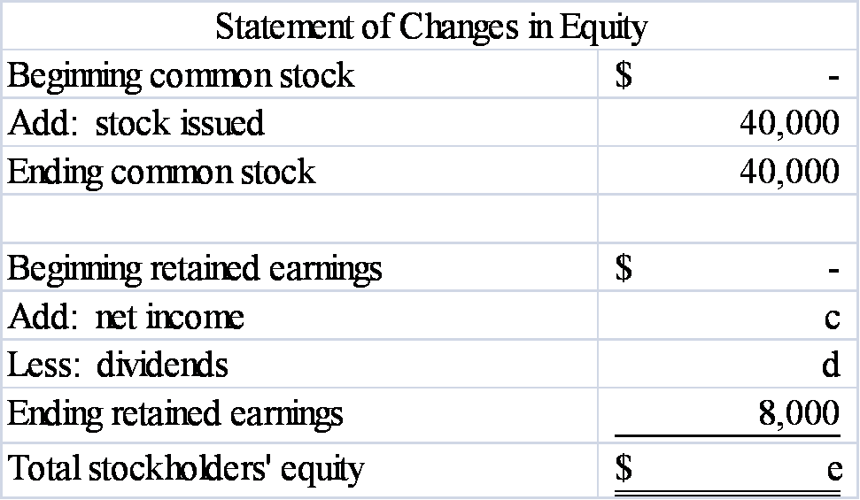  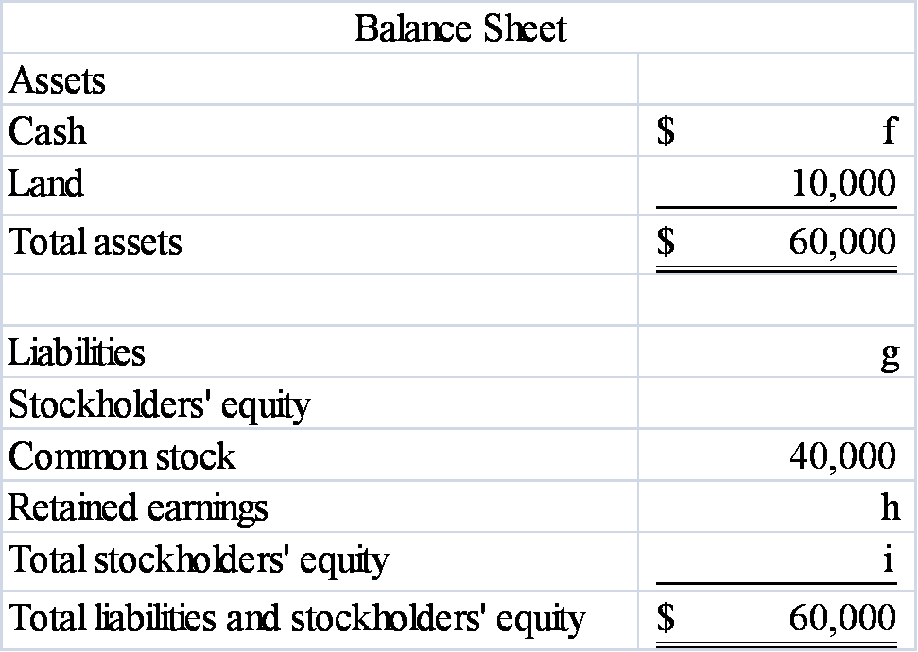  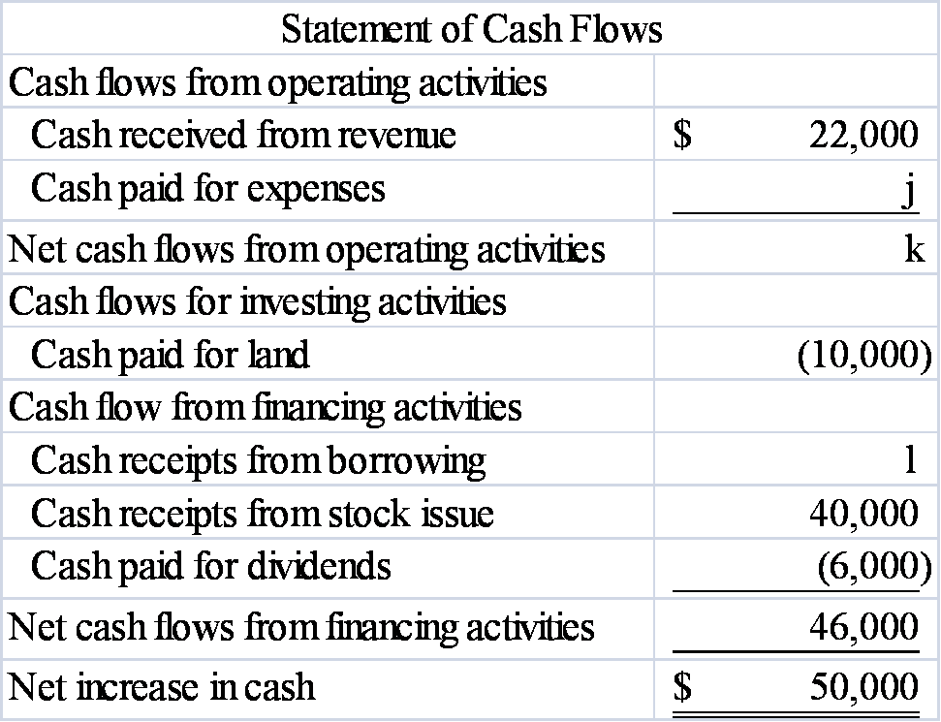

143. | The following transactions apply to the Grant Corporation for 2013, its first year in business.  1) Issued stock to investors, $24,000.  2) The company borrowed $21,000 cash from the bank.  3) Services were provided to customers and $24,000 cash was received.  4) The company loaned $5,000 to another company.  5) The company acquired land for $22,000.  6) The company paid $12,000 rent for the building where it does its business.  7) The company paid $1,600 for supplies that were used during the period.  8) The company sold the land acquired in item 5 for $22,000.  9) A dividend of $5,000 was made to the owners.  10) Repaid $10,000 of the loan described in item 2.  Required:  Prepare a statement of cash flows for 2013.

144. | Rosemont Company began operations on January 1, 2013, and on that date issued stock for $60,000 cash. In addition, Rosemont borrowed $50,000 cash from the local bank. The company provided services to its customers during 2013 and received $35,000. It purchased land for $70,000. During the year, it paid $10,000 cash for salaries and $9,000 cash for supplies that were used up in its operations. Stockholders were paid cash dividends of $8,000 during the year.  Required:  a) List the transactions from the information above (for example, issued common stock for $60,000) and indicate in which section of the statement of cash flows each transaction would be reported.  b) What would the amount be for net cash flows from operating activities?  c) What would be the amount of the total assets for the Rosemont Company at the end of 2013?  d) What would the end-of-year balance be for the retained earnings account?  e) What would the end-of-year balance be for the cash account?

145. | The Ruiz Company began operations on January 1, 2013 and on that date issued $30,000 of common stock for cash. In addition, the company borrowed $20,000 from the bank. It provided services to its customers during 2013 and received $36,000 cash. During the year, it paid $40,000 cash for land, $10,000 for salaries, and $6,000 in cash dividends to the owners.  Required:  1) Write an accounting equation and record the effects of each transaction under the appropriate heading. (Use specific accounting titles below the statement elements)  2) Prepare an income statement and a balance sheet for the 2013 accounting period.

146. | Canton Company was formed in 2013 and experienced the following accounting events during the year:  1. issued common stock for $10,000 cash  2. earned cash revenue of $15,000  3. paid cash expenses of $13,000.  These were the only events that affected the company during the year.  Required:  a) Write the accounting equation and record the effects of each accounting event under the appropriate general ledger account heading.  b) Prepare an income statement for 2013 and a balance sheet as of December 31, 2013.

147. | Flagstone Company was founded on January 1, 2013. During 2013, the company experienced the following events:  1. earned cash revenue of $25,000  2. paid cash expenses of $20,500  3. issued common stock for $15,000 cash  4. paid cash dividend of $1,000 to owners.  Required:  a) Write an accounting equation and record effects of each accounting event under appropriate general ledger account headings, showing dollar amounts of increases and decreases and totals at the end of the year.  b) Prepare the 2013 income statement and balance sheet for Flagstone Company.

148. | During 2013, Saranac Company earned $12,000 of cash revenue and paid $8,200 of cash expenses and $600 in dividends to the company's owners. Enter each of these three events into the horizontal financial statements model, below. Indicate dollar amounts of increases and decreases. For cash flows, show whether they are operating activities (OA), investing activities (IA), or financing activities (FA).  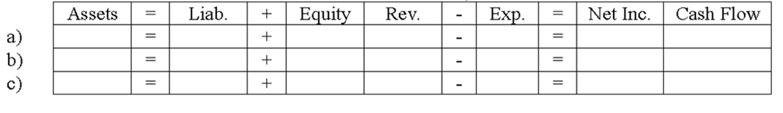

149. | During 2013, Wynona Company issued common stock to stockholders for $12,000, purchased land for $3,200 cash, and paid cash dividends of $1,000 to the company's owners. Enter each of these three events into the horizontal financial statements model, below. Indicate dollar amounts of increases and decreases. For cash flows, show whether they are operating activities (OA), investing activities (IA), or financing activities (FA).  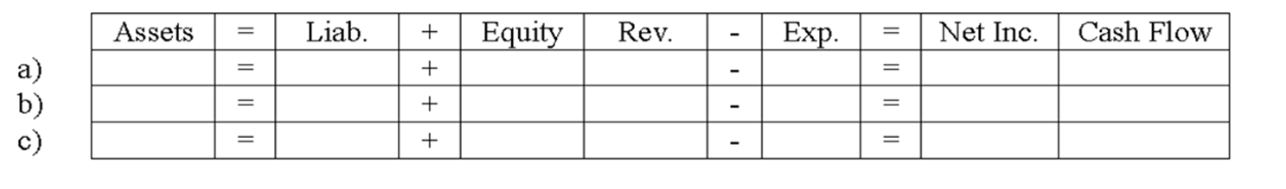

150. | During 2013, XYZ Company issued common stock to stockholders for $10,000; purchased land for $2,000 cash; provided services to customers for $8,000; paid cash operating expenses of $6,200; and paid cash dividends of $1,000 to the company's owners. Enter each of these events into the horizontal financial statements model, below. Indicate dollar amounts of increases and decreases. For cash flows, show whether they are operating activities (OA), investing activities (IA), or financing activities (FA).  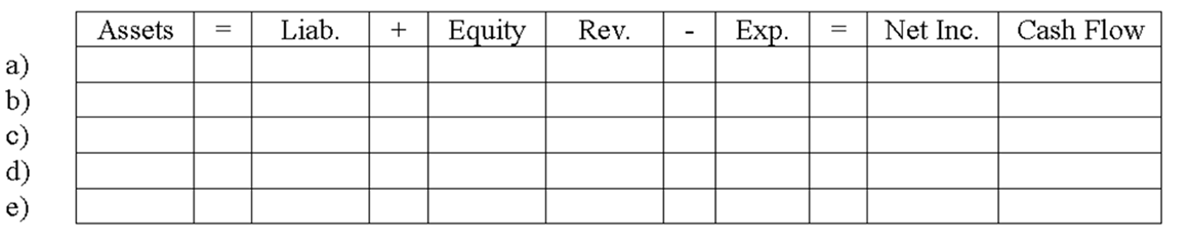

Chapter 01 An Introduction to Accounting Answer Key
Short Answer Questions
1. | Indicate how each event affects the elements of financial statements. Use the following letters to record your answer in the box shown below each element. You do not need to enter amounts.  Ferguson Co. issued common stock for $50,000 cash.  (I) (N) (I) (N) (N) (N) (I)  Feedback: Issuing common stock is an asset source transaction that increases the business's assets (cash) and its stockholders' equity (common stock). It does not affect the income statement, but is reported as a cash flow from financing activities in the statement of cash flows.

AACSB: Analytic
AICPA BB: Critical Thinking
AICPA FN: Reporting
Blooms: Understand
Difficulty: 1 Easy
Learning Objective: 01-07 Record business events using a horizontal financial statements model.
Topic: The Horizontal Financial Statements Model

2. | Indicate how each event affects the elements of financial statements. Use the following letters to record your answer in the box shown below each element. You do not need to enter amounts.  Rodriguez Co. borrowed $20,000 cash from Century Bank.  (I) (I) (N) (N) (N) (N) (I)  Feedback: Borrowing cash is an asset source transaction that increases a business's assets (cash) and its liabilities (notes payable). It does not affect the income statement, but is reported as a cash flow from financing activities in the statement of cash flows.

AACSB: Analytic
AICPA BB: Critical Thinking
AICPA FN: Reporting
Blooms: Understand
Difficulty: 1 Easy
Learning Objective: 01-07 Record business events using a horizontal financial statements model.
Topic: The Horizontal Financial Statements Model

3. | Indicate how each event affects the elements of financial statements. Use the following letters to record your answer in the box shown below each element. You do not need to enter amounts.  Vincent Co. provided services for $25,000 cash.  (I) (N) (I) (I) (N) (I) (I)  Feedback: This is an asset source transaction that increases the business's assets (cash). When a business provides services, it earns revenue. Revenue increases net income, which will increase equity (retained earnings) at the end of the accounting period. This event is reported as a cash flow from operating activities in the statement of cash flows.

AACSB: Analytic
AICPA BB: Critical Thinking
AICPA FN: Reporting
Blooms: Understand
Difficulty: 1 Easy
Learning Objective: 01-07 Record business events using a horizontal financial statements model.
Topic: The Horizontal Financial Statements Model

4. | Indicate how each event affects the elements of financial statements. Use the following letters to record your answer in the box shown below each element. You do not need to enter amounts.  Patterson Co. paid $50,000 cash to purchase land.  (N) (N) (N) (N) (N) (N) (D)  Feedback: Purchasing land for cash is an asset exchange transaction that increases one asset (land) and decreases another asset (cash). It does not affect the income statement, and is reported as an investing activity in the statement of cash flows.

AACSB: Analytic
AICPA BB: Critical Thinking
AICPA FN: Reporting
Blooms: Understand
Difficulty: 1 Easy
Learning Objective: 01-07 Record business events using a horizontal financial statements model.
Topic: The Horizontal Financial Statements Model

5. | Indicate how each event affects the elements of financial statements. Use the following letters to record your answer in the box shown below each element. You do not need to enter amounts.  Greene Co. paid $211,000 cash in salaries to its employees.  (D) (N) (D) (N) (I) (D) (D)  Feedback: Paying an expenses such as salaries is an asset use transaction that decreases the business's assets (cash) and decreases its equity (retained earnings). Note that the expense decreases net income, and will decrease retained earnings at the end of the accounting period. It is reported as a cash flow for operating activities in the statement of cash flows.

AACSB: Analytic
AICPA BB: Critical Thinking
AICPA FN: Reporting
Blooms: Understand
Difficulty: 1 Easy
Learning Objective: 01-07 Record business events using a horizontal financial statements model.
Topic: The Horizontal Financial Statements Model

6. | Indicate how each event affects the elements of financial statements. Use the following letters to record your answer in the box shown below each element. You do not need to enter amounts.  Walsh Co. paid a $50,000 cash dividend to its owners.  (D) (N) (D) (N) (N) (N) (D)  Feedback: Paying a cash dividend is an asset use transaction that decreases a business's assets (cash) and its equity. The dividends account will decrease the retained earnings at the end of the accounting period. It does not affect net income, and is reported as a cash flow for financing activities in the statement of cash flows.

AACSB: Analytic
AICPA BB: Critical Thinking
AICPA FN: Reporting
Blooms: Understand
Difficulty: 2 Medium
Learning Objective: 01-07 Record business events using a horizontal financial statements model.
Topic: The Horizontal Financial Statements Model

7. | Indicate how each event affects the elements of financial statements. Use the following letters to record your answer in the box shown below each element. You do not need to enter amounts.  Vegas Co. issued a note to purchase a building.  (I) (I) (N) (N) (N) (N) (N)  Feedback: Issuing a note to purchase a building is an asset source transaction that increases a business's assets (building) and increases its liabilities (notes payable). It does not affect net income or the statement of cash flows.

AACSB: Analytic
AICPA BB: Critical Thinking
AICPA FN: Reporting
Blooms: Understand
Difficulty: 2 Medium
Learning Objective: 01-07 Record business events using a horizontal financial statements model.
Topic: The Horizontal Financial Statements Model

8. | Name the group that has the primary authority for establishing U.S. GAAP.  Financial Accounting Standards Board  Feedback: The Financial Accounting Standards Board (FASB) is a privately funded organization with the primary authority for establishing accounting standards in the United States

AACSB: Reflective Thinking
AICPA BB: Critical Thinking
AICPA FN: Reporting
Blooms: Remember
Difficulty: 1 Easy
Learning Objective: 01-01 Explain the role of accounting in society.
Topic: Measurement Rules

9. | Who are the three distinct types of participants in a market? Briefly describe the role of each group of participants.  Markets include consumers, conversion agents, and resource owners. Consumers use resources. Conversion agents are businesses that convert resources to the form that consumers want. Resource owners control the distribution of resources to conversion agents.

AACSB: Reflective Thinking
AICPA BB: Industry
AICPA FN: Research
Blooms: Understand
Difficulty: 2 Medium
Learning Objective: 01-01 Explain the role of accounting in society.
Topic: Using Free Markets to Set Resource Priorities

10. | What is meant by the term "stakeholders?"  Stakeholders are the parties that are interested in operations of an organization. Stakeholders often are users or potential users of accounting information. Stakeholders include resource providers, financial analysts, brokers, attorneys, government regulators and news reporters.

AACSB: Reflective Thinking
AICPA BB: Industry
AICPA FN: Reporting
Blooms: Remember
Difficulty: 2 Medium
Learning Objective: 01-01 Explain the role of accounting in society.
Topic: Using Free Markets to Set Resource Priorities

11. | What is meant by the term "global GAAP"? How does it impact U.S. companies? What body is responsible for setting global standards?  International Financial Reporting Standards (IFRS) have been adopted by most countries outside of the United States, and are becoming "global GAAP." Many believe that U.S. companies will be allowed to use either IFRS or U.S. GAAP in the future, and there is an ongoing process to reduce the differences between IFRS and GAAP. The International Accounting Standards Board (IASB), headquartered in London, is responsible for forming these standards.

AACSB: Reflective Thinking
AICPA BB: Global
AICPA FN: Reporting
Blooms: Understand
Difficulty: 2 Medium
Learning Objective: 01-01 Explain the role of accounting in society.
Topic: Measurement Rules

12. | Briefly distinguish between financial accounting and managerial accounting.  Financial accounting is designed to satisfy the needs of external resource providers (external users), and must adhere to Generally Accepted Accounting Principles. Managerial accounting, however, provides information that is useful to managers within a business (internal users), and does not have to low GAAP.

AACSB: Communication
AACSB: Reflective Thinking
AICPA BB: Industry
AICPA FN: Reporting
Blooms: Understand
Difficulty: 2 Medium
Learning Objective: 01-01 Explain the role of accounting in society.
Topic: Types of Accounting Information

13. | Explain some of the accounting similarities and differences between not-for-profit organizations and for-profit businesses.  Similarities: Both types of organizations add value through resource transformation. Accounting information can be useful in measuring the goods and services provided and the efficiency and effectiveness in producing goods and providing services.  Difference: Not-for-profit organizations exist for a purpose other than earning a profit, while making a profit is a primary goal for businesses.

AACSB: Communication
AACSB: Reflective Thinking
AICPA BB: Industry
AICPA FN: Research
Blooms: Understand
Difficulty: 2 Medium
Learning Objective: 01-01 Explain the role of accounting in society.
Topic: Types of Accounting Information

14. | What financial statement elements are reported on a balance sheet?  A business's balance sheet shows the elements: assets, liabilities, and equity.

AACSB: Reflective Thinking
AICPA BB: Critical Thinking
AICPA FN: Reporting
Blooms: Remember
Difficulty: 2 Medium
Learning Objective: 01-02 Construct an accounting equation and show how business events affect the equation.
Topic: Elements of Financial Statements

15. | From what three sources does a business obtain its assets?  A business obtains its assets from creditors, from investors, and from operations.

AACSB: Reflective Thinking
AICPA BB: Critical Thinking
AICPA FN: Risk Analysis
Blooms: Understand
Difficulty: 2 Medium
Learning Objective: 01-02 Construct an accounting equation and show how business events affect the equation.
Topic: The Accounting Equation

16. | How does providing services for cash affect the accounting equation? Is it considered an asset source, asset use, or asset exchange transaction?  Providing services for cash increases assets and increases equity. It is considered an asset source transaction.  Feedback: Providing services for cash increases cash, an asset, and revenue increases equity (retained earnings).

AACSB: Analytic
AACSB: Reflective Thinking
AICPA BB: Critical Thinking
AICPA FN: Reporting
Blooms: Understand
Difficulty: 2 Medium
Learning Objective: 01-03 Interpret information shown in an accounting equation.
Learning Objective: 01-04 Classify business events as asset source; use; or exchange transactions.
Topic: Asset Source Transactions

17. | How does the payment of cash dividends to stockholders affect the accounting equation? Is it considered an asset source, asset use, or asset exchange transaction?  Payment of cash dividends decreases assets and decreases equity. It is considered an asset use transaction.  Feedback: Paying dividends decreases assets (cash) and decreases equity (retained earnings).

AACSB: Analytic
AACSB: Reflective Thinking
AICPA BB: Critical Thinking
AICPA FN: Reporting
Blooms: Understand
Difficulty: 2 Medium
Learning Objective: 01-03 Interpret information shown in an accounting equation.
Learning Objective: 01-04 Classify business events as asset source; use; or exchange transactions.
Topic: Asset Use Transactions

18. | If the total equity claimed by owners of Ping Construction is $50,000 and liabilities are $25,000, what are total assets?  $75,000  Feedback: Assets = Liabilities $25,000 + Equity $50,000; Assets = $75,000

AACSB: Analytic
AACSB: Reflective Thinking
AICPA BB: Critical Thinking
AICPA FN: Reporting
Blooms: Understand
Difficulty: 2 Medium
Learning Objective: 01-02 Construct an accounting equation and show how business events affect the equation.
Topic: The Accounting Equation

19. | What is meant by the term double-entry bookkeeping?  All transactions affect the accounting equation in at least two places.  Feedback: Double-entry bookkeeping is necessary to maintain the balance of the accounting equation, assets = liabilities + equity.

AACSB: Analytic
AACSB: Reflective Thinking
AICPA BB: Critical Thinking
AICPA FN: Reporting
Blooms: Understand
Difficulty: 1 Easy
Learning Objective: 01-03 Interpret information shown in an accounting equation.
Topic: Asset Source Transactions

20. | Give three examples of asset use transactions.  Paid loan, paid expense, and paid dividends to stockholders.  Feedback: Asset use transactions involve a decrease in assets (for example, cash) and will also result in a decrease in either liabilities (paid loan) or equity (paid expense or dividends).

AACSB: Analytic
AACSB: Reflective Thinking
AICPA BB: Critical Thinking
AICPA FN: Reporting
Blooms: Understand
Difficulty: 2 Medium
Learning Objective: 01-04 Classify business events as asset source; use; or exchange transactions.
Topic: Asset Use Transactions

21. | What does a company's statement of cash flow tell you about the company?  The statement of cash flows tells how a company obtained and used cash during the accounting period.  Feedback: The statement of cash flows explains the change in cash from the beginning to the end of the period.

AACSB: Analytic
AACSB: Reflective Thinking
AICPA BB: Critical Thinking
AICPA FN: Reporting
Blooms: Understand
Difficulty: 1 Easy
Learning Objective: 01-05 Use general ledger account information to prepare four financial statements.
Topic: Statement of Cash Flows

22. | If a corporation issues common stock for $20,000 cash, in which section of the statement of cash flows would this transaction be reported?  Financing activities  Feedback: All cash exchanged between a company and its stockholders is considered a financing activity.

AACSB: Analytic
AACSB: Reflective Thinking
AICPA BB: Critical Thinking
AICPA FN: Reporting
Blooms: Remember
Difficulty: 1 Easy
Learning Objective: 01-05 Use general ledger account information to prepare four financial statements.
Topic: Statement of Cash Flows

23. | Which types of accounts are closed out to retained earnings at the end of an accounting period?  Revenues, expenses, and dividends are temporary or nominal accounts and are closed at the end of the accounting period.  Feedback: These accounts are called temporary, or nominal, accounts. Note that dividends are reported on neither the income statement nor the balance sheet.

AACSB: Analytic
AACSB: Reflective Thinking
AICPA BB: Critical Thinking
AICPA FN: Reporting
Blooms: Understand
Difficulty: 1 Easy
Learning Objective: 01-05 Use general ledger account information to prepare four financial statements.
Topic: The Closing Process

24. | Name and briefly describe each of the four financial statements.  The balance sheet lists the assets of a business and corresponding claims on those assets.  The income statement lists the revenues and expenses of an organization and measures the difference between the asset increases and the asset decreases associated with operating a business.  The statement of changes in stockholders' equity is used to explain the effects of transactions on stockholders' equity during an accounting period.  The statement of cash flows explains the change (sources and uses) between the beginning and ending cash balances during the accounting period.

AACSB: Analytic
AACSB: Reflective Thinking
AICPA BB: Critical Thinking
AICPA FN: Reporting
Blooms: Understand
Difficulty: 3 Hard
Learning Objective: 01-05 Use general ledger account information to prepare four financial statements.
Topic: Income Statement, Balance Sheet, Statement of Changes in Equity, Statement of Cash Flows

25. | Define the term "accounting period." How does this term relate to the "matching concept" as it pertains to the income statement?  An accounting period is the span of time covered by the financial statements, normally one year; the span of time for which income is measured. On the income statement, revenues and expenses that are incurred in the same accounting period are matched together. This is known as the matching concept.

AACSB: Analytic
AACSB: Reflective Thinking
AICPA BB: Critical Thinking
AICPA FN: Reporting
Blooms: Understand
Difficulty: 2 Medium
Learning Objective: 01-05 Use general ledger account information to prepare four financial statements.
Topic: Income Statement and the Matching Concept

Multiple Choice Questions
26. | Which of the following groups has the primary responsibility for establishing generally accepted accounting principles for business entities in the United States?  A. Internal Revenue Service.  B. U.S. Congress.  C. Financial Accounting Standards Board.  D. International Accounting Standards Board.  The Financial Accounting Standards Board is a privately funded group charged with establishing accounting standards for the U.S. It is not a branch of the U.S. government.

AACSB: Reflective Thinking
AICPA BB: Critical Thinking
AICPA FN: Reporting
Accessibility: Keyboard Navigation
Blooms: Remember
Difficulty: 1 Easy
Learning Objective: 01-01 Explain the role of accounting in society.
Topic: Measurement Rules

27. | The Jefferson Company is a manufacturer of antique reproduction furniture. Which term best describes Jefferson's role in society?  A. Consumer  B. Regulatory Agency  C. Conversion Agent  D. Resource Owner  Businesses serve as conversion agents in the marketplace, transforming basic resources provided by resource owners into goods and services that consumers demand. Regulatory agencies set policies that affect the way that businesses operate.

AACSB: Reflective Thinking
AICPA BB: Industry
AICPA FN: Reporting
Accessibility: Keyboard Navigation
Blooms: Understand
Difficulty: 2 Medium
Learning Objective: 01-01 Explain the role of accounting in society.
Topic: Using Free Markets to Set Resource Priorities

28. | Which resource provider typically receives first priority when resources are divided as part of a business's liquidation?  A. The company's managers  B. Stockholders  C. Creditors  D. Owners  In a business liquidation, creditors receive first priority in the distribution of resources. After creditors, the stockholders (also called owners) receive what is left.

AACSB: Reflective Thinking
AICPA BB: Legal
AICPA FN: Reporting
Accessibility: Keyboard Navigation
Blooms: Understand
Difficulty: 1 Easy
Learning Objective: 01-01 Explain the role of accounting in society.
Topic: Using Free Markets to Set Resource Priorities

29. | Which type of accounting information is intended to satisfy the needs of external users of accounting information?  A. Cost accounting  B. Financial accounting  C. Tax accounting  D. Managerial accounting  Financial accounting is intended to satisfy the needs of external users of accounting information. Managerial accounting, including cost accounting, is intended for the needs of internal users, or managers, of a business. Tax accounting is specifically intended for tax regulatory agencies.

AACSB: Reflective Thinking
AICPA BB: Critical Thinking
AICPA FN: Reporting
Accessibility: Keyboard Navigation
Blooms: Understand
Difficulty: 1 Easy
Learning Objective: 01-01 Explain the role of accounting in society.
Topic: Types of Accounting Information

30. | Managerial accounting provides information primarily to which of the following groups or individuals?  A. Internal users  B. Shareholders  C. External users  D. Internal users and Shareholders  Managerial accounting provides information primarily for internal users, or managers, of businesses. External users, including shareholders, use financial accounting information.

AACSB: Reflective Thinking
AICPA BB: Industry
AICPA FN: Decision Making
Accessibility: Keyboard Navigation
Blooms: Understand
Difficulty: 1 Easy
Learning Objective: 01-01 Explain the role of accounting in society.
Topic: Types of Accounting Information

31. | "GAAP" stands for  A. Government Authorized Accounting Procedures.  B. Generally Applied Accounting Procedures.  C. Generally Accepted Accounting Principles.  D. Generally Authorized Auditing Principles.  Generally Accepted Accounting Principles are established by the Financial Accounting Standards Board.

AACSB: Reflective Thinking
AICPA BB: Critical Thinking
AICPA FN: Reporting
Accessibility: Keyboard Navigation
Blooms: Remember
Difficulty: 1 Easy
Learning Objective: 01-01 Explain the role of accounting in society.
Topic: Measurement Rules

32. | "IASB" stands for  A. Internal Accounting Standards Board.  B. Internationally Authorized Statements Board.  C. International Accounting Standards Board.  D. Initial Accounting Statements Bureau.  The International Accounting Standards Board establishes accounting standards for most countries outside of the U.S.

AACSB: Reflective Thinking
AICPA BB: Critical Thinking
AICPA BB: Global
AICPA FN: Reporting
Accessibility: Keyboard Navigation
Blooms: Remember
Difficulty: 1 Easy
Learning Objective: 01-01 Explain the role of accounting in society.
Topic: Measurement Rules

33. | Which of the following items is an example of revenue?  A. Cash received from a bank loan  B. Cash received from customers at the time services were provided  C. Cash investments made by owners  D. All of these  Cash received from providing services to customers is an example of revenue. Cash received from a bank loan results in a liability, notes payable. Cash investments made by owners increase the stockholders' equity account common stock.

AACSB: Reflective Thinking
AICPA BB: Critical Thinking
AICPA FN: Reporting
Accessibility: Keyboard Navigation
Blooms: Understand
Difficulty: 1 Easy
Learning Objective: 01-01 Explain the role of accounting in society.
Topic: Measurement Rules

34. | Which of the following is not an element of the financial statements?  A. Cash  B. Revenue  C. Assets  D. Distributions  Cash is not an element of the financial statements. It is an account that is part of the element assets.

AACSB: Reflective Thinking
AICPA BB: Critical Thinking
AICPA FN: Reporting
Accessibility: Keyboard Navigation
Blooms: Understand
Difficulty: 2 Medium
Learning Objective: 01-02 Construct an accounting equation and show how business events affect the equation.
Topic: Elements of Financial Statements

35. | The balance sheet of the Chesapeake Company contained the following accounts and balances:  Based on the above information only, the amount or balance for Land must be  A. $450.  B. $750.  C. $150.  D. $1,350.  Assets = Liabilities + Equity; Cash $600 + Land? = Notes Payable $300 + Equity $450; Land = $150

AACSB: Analytic
AACSB: Reflective Thinking
AICPA BB: Critical Thinking
AICPA FN: Reporting
Blooms: Apply
Difficulty: 2 Medium
Learning Objective: 01-02 Construct an accounting equation and show how business events affect the equation.
Topic: The Accounting Equation

36. | Vandever Company's balance sheet reported assets of $42,000, liabilities of $15,000 and common stock of $12,000 as of December 31, 2012. If Retained Earnings on the December 31, 2013 balance sheet is $18,000 and Vandever paid a $14,000 dividend during 2013, then the amount of net income for 2013 was which of the following?  A. $17,000  B. $15,000  C. $3,000  D. None of these  If assets on December 31, 2012 totaled $42,000, total claims (including liabilities, common stock, and retained earnings) on that date must have also been $42,000. If liabilities were $15,000 and common stock was $12,000, retained earnings on December 31, 2012 must have been $15,000. At the end of 2013, the company reported $18,000 in retained earnings, a $3,000 increase. During 2013, Vandever paid a $14,000 cash dividend, which reduced retained earnings. Therefore, 2013 net income must have been $3,000 greater than the dividend paid. $14,000 + $3,000 = $17,000.

AACSB: Analytic
AACSB: Reflective Thinking
AICPA BB: Critical Thinking
AICPA FN: Reporting
Accessibility: Keyboard Navigation
Blooms: Analyze
Difficulty: 3 Hard
Learning Objective: 01-03 Interpret information shown in an accounting equation.
Topic: The Accounting Equation

37. | Hacienda Company issued common stock for $250,000 cash. As a result of this event,  A. assets increased.  B. retained earnings increased.  C. equity increased.  D. assets increased and equity increased.  Issuing common stock increases both assets (cash) and equity (common stock). It does not increase retained earnings because no revenue is recognized.

AACSB: Analytic
AACSB: Reflective Thinking
AICPA BB: Critical Thinking
AICPA FN: Reporting
Accessibility: Keyboard Navigation
Blooms: Understand
Difficulty: 2 Medium
Learning Objective: 01-03 Interpret information shown in an accounting equation.
Topic: Asset Source Transactions

38. | If Boyd Company reported assets of $500 and liabilities of $200, Boyd's total claims totaled  A. $300.  B. $500.  C. $700.  D. none of these.  In the accounting equation, assets equal claims (liabilities + equity). If assets are $500, total claims must also be $500.

AACSB: Analytic
AACSB: Reflective Thinking
AICPA BB: Critical Thinking
AICPA FN: Measurement
AICPA FN: Reporting
Accessibility: Keyboard Navigation
Blooms: Apply
Difficulty: 1 Easy
Learning Objective: 01-03 Interpret information shown in an accounting equation.
Topic: The Accounting Equation

39. | If a company's total assets decreased while liabilities and common stock were unchanged, and no dividends were paid, then  A. cash flow from operating activities was greater than cash flow from investing activities.  B. retained earnings were less than net income during the period.  C. revenues were less than expenses.  D. the company must have purchased assets with cash.  If a company's total assets decreased while liabilities and common stock were unchanged, retained earnings must have decreased. The only two things that cause retained earnings to decrease during an accounting period are the payment of dividends and recording a net loss for the period. A net loss results when revenues are less than expenses.

AACSB: Analytic
AACSB: Reflective Thinking
AICPA BB: Critical Thinking
AICPA FN: Reporting
Accessibility: Keyboard Navigation
Blooms: Analyze
Difficulty: 3 Hard
Learning Objective: 01-03 Interpret information shown in an accounting equation.
Topic: The Accounting Equation

40. | Varghese Company paid cash to purchase land. As a result of this accounting event  A. total assets decreased.  B. total assets were unaffected.  C. total equity decreased.  D. none of these.  Paying cash for land is an asset exchange transaction that increases one asset (land) and decreases another asset (land). The result is no overall change in total assets.

AACSB: Analytic
AACSB: Reflective Thinking
AICPA BB: Critical Thinking
AICPA FN: Reporting
Accessibility: Keyboard Navigation
Blooms: Understand
Difficulty: 1 Easy
Learning Objective: 01-03 Interpret information shown in an accounting equation.
Topic: Asset Exchange Transactions

41. | The total equity of Timberlake Company at the beginning of 2013 amounted to $5,500. During 2013 the company reported net income of $1,800 and paid a $500 dividend. If retained earnings at the end of 2013 is $2,200, what was beginning common stock?  A. $3,300  B. $2,800  C. $1,300  D. $4,600  During 2013 net income increased retained earnings by $1,800 and dividends decreased retained earnings by $500, a net increase of $1,300. If ending retained earnings is $2,200, beginning retained earnings must have been $1,300 less than that, or $900. With a total of $5,500 in equity at the beginning of the year, common stock must have equaled $4,600 ($5,500 - $900).

AACSB: Analytic
AACSB: Reflective Thinking
AICPA BB: Critical Thinking
AICPA FN: Reporting
Accessibility: Keyboard Navigation
Blooms: Analyze
Difficulty: 3 Hard
Learning Objective: 01-03 Interpret information shown in an accounting equation.
Topic: The Accounting Equation

42. | A company mistakenly recorded a cash purchase of land as an expense. As a result of this error  A. Assets were understated and equity was overstated.  B. Assets and equity were understated.  C. Assets and equity were overstated.  D. Assets were overstated and equity was understated.  If the transaction had been recorded correctly, one asset (land) would have increased and another asset (cash) would have decreased, causing no net change in total assets. As the transaction was recorded, the asset cash decreased and the expense caused equity to decrease as well. Therefore, assets and equity were understated.

AACSB: Analytic
AACSB: Reflective Thinking
AICPA BB: Resource Management
AICPA FN: Reporting
Accessibility: Keyboard Navigation
Blooms: Apply
Difficulty: 3 Hard
Learning Objective: 01-03 Interpret information shown in an accounting equation.
Topic: Asset Exchange Transactions

43. | As of December 31, 2013, Bloch Company had $3,800 of assets, $1,600 of liabilities and $700 of retained earnings. The balance in the common stock account on the December 31, 2013 balance sheet was  A. $2,900.  B. $3,800.  C. $1,500.  D. none of these.  If assets total $3,800, claims must also total $3,800. Claims include liabilities, common stock and retained earnings. Because liabilities and retained earnings equal $2,300, common stock must be $1,500.

AACSB: Analytic
AACSB: Reflective Thinking
AICPA BB: Critical Thinking
AICPA FN: Measurement
AICPA FN: Reporting
Accessibility: Keyboard Navigation
Blooms: Apply
Difficulty: 1 Easy
Learning Objective: 01-02 Construct an accounting equation and show how business events affect the equation.
Topic: The Accounting Equation

44. | On January 1, 2013, Baird Company had beginning balances as lows:  Assets = $2,250  Liabilities = $620  Common Stock = $800  During 2013, Baird paid dividends to its stockholders of $900. Given that ending retained earnings was $600, what was Baird's net income for the 2013 accounting period?  A. $770  B. $830  C. $1,250  D. $500  On January 1: Assets = Liabilities + Common Stock + Retained Earnings  $2,250 = $620 + $800 + Retained Earnings  Retained Earnings = $830  $830 + Net Income - $900 = $600  Net Income = $670

AACSB: Analytic
AACSB: Reflective Thinking
AICPA BB: Critical Thinking
AICPA FN: Measurement
AICPA FN: Reporting
Accessibility: Keyboard Navigation
Blooms: Apply
Difficulty: 3 Hard
Learning Objective: 01-03 Interpret information shown in an accounting equation.
Topic: The Accounting Equation

45. | The transaction, "earned cash revenue," affects which two accounts?  A. Revenue and Salaries Expense  B. Cash and Notes Payable  C. Cash and Revenue  D. Cash and Dividends  Earning cash revenue increases a company's assets (cash) and equity (revenue, which closes to retained earnings).

AACSB: Analytic
AACSB: Reflective Thinking
AICPA BB: Resource Management
AICPA FN: Reporting
Accessibility: Keyboard Navigation
Blooms: Understand
Difficulty: 1 Easy
Learning Objective: 01-03 Interpret information shown in an accounting equation.
Topic: Asset Source Transactions

46. | During 2013, Bledsoe Company earned $6,700 of cash revenue, paid cash dividends of $950 to owners and paid $5,000 for cash expenses. Liabilities were unchanged. Which of the following accurately describes the effect of these events on the elements of the company's financial statements?  A. Assets increased by $7,700.  B. Assets increased by $750.  C. Equity increased by $2,700.  D. Assets increased by $750 and Equity increased by $2,700.  Revenue - Expenses - Dividends = Change in Equity  $6,700 - $950 - $5,000 = $750 change in equity. If there was no change in liabilities, the change in assets must also equal $750.

AACSB: Analytic
AACSB: Reflective Thinking
AICPA BB: Resource Management
AICPA FN: Measurement
AICPA FN: Reporting
Accessibility: Keyboard Navigation
Blooms: Apply
Difficulty: 2 Medium
Learning Objective: 01-03 Interpret information shown in an accounting equation.
Topic: The Accounting Equation

47. | At the end of 2013, retained earnings for the Bisk Company was $1,750. Revenue earned by the company in 2013 was $2,000, expenses paid during the period were $1,100, and dividends paid during the period were $500. Based on this information alone, retained earnings at the beginning of 2013 was  A. $850.  B. $2,150.  C. $1,350.  D. $4,000.  Beginning Retained Earnings + Revenue - Expenses - Dividends = Ending Retained Earnings  Beginning Retained Earnings + $2,000 - $1,100 - $500 = $1,750  Beginning Retained Earnings = $1,350

AACSB: Analytic
AACSB: Reflective Thinking
AICPA BB: Resource Management
AICPA FN: Measurement
AICPA FN: Reporting
Accessibility: Keyboard Navigation
Blooms: Analyze
Difficulty: 3 Hard
Learning Objective: 01-03 Interpret information shown in an accounting equation.
Topic: The Accounting Equation

48. | Which of the following is NOT an asset use transaction?  A. Paying cash to purchase land  B. Paying cash expenses  C. Paying off the principal of a loan  D. All of these are asset use transactions  Paying cash to purchase land is an asset exchange transaction.

AACSB: Analytic
AACSB: Reflective Thinking
AICPA BB: Resource Management
AICPA FN: Measurement
Accessibility: Keyboard Navigation
Blooms: Understand
Difficulty: 1 Easy
Learning Objective: 01-04 Classify business events as asset source; use; or exchange transactions.
Topic: Asset Use Transactions

49. | Borrowing cash from the bank is an example of which type of transaction?  A. Asset exchange  B. Claims use  C. Asset use  D. Asset source  Borrowing cash is an asset source transaction that increases a business's assets (cash) and increases its liabilities (notes payable).

AACSB: Analytic
AACSB: Reflective Thinking
AICPA BB: Resource Management
AICPA FN: Measurement
Accessibility: Keyboard Navigation
Blooms: Understand
Difficulty: 1 Easy
Learning Objective: 01-04 Classify business events as asset source; use; or exchange transactions.
Topic: Asset Source Transactions

50. | Which of the following could describe the effects of an asset exchange transaction on a company's financial statements?  A.  B.  C.  D.  An asset exchange transaction is one that increases one asset account and decreases another, resulting in no net change in assets. There are no changes to the company's liabilities and equity either. If one of the asset accounts affected is cash, there will be an effect on cash flows.

AACSB: Analytic
AACSB: Reflective Thinking
AICPA BB: Critical Thinking
AICPA FN: Measurement
Blooms: Understand
Difficulty: 1 Easy
Learning Objective: 01-04 Classify business events as asset source; use; or exchange transactions.
Topic: Asset Exchange Transactions

51. | Which of the following describes the effects of an asset use transaction on a company's financial statements?  A.  B.  C.  D.  An asset use transaction is one that decreases a business's assets and increases either liabilities or equity. An asset use transaction may or may not affect expenses. If the asset account decreased is cash, there will be an effect on cash flows. Therefore, any of the given models may represent an asset use transaction.

AACSB: Analytic
AACSB: Reflective Thinking
AICPA BB: Critical Thinking
AICPA FN: Measurement
Blooms: Understand
Difficulty: 3 Hard
Learning Objective: 01-04 Classify business events as asset source; use; or exchange transactions.
Topic: Asset Use Transactions

52. | Which of the following statements regarding cash transactions is true?  A. Purchasing land for cash results in no net change in assets.  B. Issuance of stock to owners increases assets.  C. Expense transactions increase assets.  D. Purchasing land for cash results in no net change in assets and Issuance of stock to owners increases assets.  Purchasing land for cash is an asset exchange transaction that does not affect total assets. Issuing stock to owners is an asset source transaction that increases assets. Expense transactions do not increase assets.

AACSB: Analytic
AACSB: Reflective Thinking
AICPA BB: Resource Management
AICPA FN: Reporting
Accessibility: Keyboard Navigation
Blooms: Understand
Difficulty: 1 Easy
Learning Objective: 01-04 Classify business events as asset source; use; or exchange transactions.
Topic: Asset Source and Asset Exchange Transactions

53. | Which of the following items appears in the investing activities section of the statement of cash flows?  A. Cash outflow for the purchase of a computer.  B. Cash inflow from the issuance of common stock.  C. Cash outflow for the payment of dividends.  D. Cash inflow from interest revenue.  Purchasing a computer (a long-lived asset) for cash is an investing activity. Issuing common stock and paying dividends are both financing activities. Cash inflow from interest revenue is an operating activity.

AACSB: Analytic
AACSB: Reflective Thinking
AICPA BB: Resource Management
AICPA FN: Reporting
Accessibility: Keyboard Navigation
Blooms: Understand
Difficulty: 2 Medium
Learning Objective: 01-05 Use general ledger account information to prepare four financial statements.
Topic: Statement of Cash Flows

54. | Jacks Company had a net increase in cash from operating activities of $8,000 and a net decrease in cash from financing activities of $1,000. If the beginning and ending cash balances for the company were $3,000 and $11,000, then net cash change from investing activities was:  A. an outflow or decrease of $1,000.  B. an inflow or increase of $2,000.  C. an inflow or increase of $1,000.  D. zero.  Beginning cash balance + Increase from operating activities - Decrease from financing activities +/- Increase or decrease from investing activities = Ending cash balance  $3,000 + $8,000 - $1,000 +/- Increase or decrease from investing activities = $11,000  $1,000 = Increase from investing activities

AACSB: Analytic
AACSB: Reflective Thinking
AICPA BB: Resource Management
AICPA FN: Measurement
AICPA FN: Reporting
Accessibility: Keyboard Navigation
Blooms: Understand
Difficulty: 1 Easy
Learning Objective: 01-05 Use general ledger account information to prepare four financial statements.
Topic: Statement of Cash Flows

55. | The year-end financial statements of Greenway Company contained the following elements and corresponding amounts: Assets = $20,000; Liabilities = ?; Common Stock = $5,000; Revenue = $11,000; Dividends = $750; Beginning Retained Earnings = $3,750; Ending Retained Earnings = $7,000.  Based on this information, the amount of expenses on Greenway's income statement was  A. $7,000.  B. $7,750.  C. $14,000.  D. $3,250.  Beginning retained earnings + Revenue - Expenses - Dividends = Ending retained earnings  $3,750 + $11,000 - Expenses - $750 = $7,000  Expenses = $7,000

AACSB: Analytic
AACSB: Reflective Thinking
AICPA BB: Critical Thinking
AICPA FN: Measurement
AICPA FN: Reporting
Accessibility: Keyboard Navigation
Blooms: Apply
Difficulty: 2 Medium
Learning Objective: 01-07 Record business events using a horizontal financial statements model.
Topic: The Horizontal Statements Model

56. | The year-end financial statements of Greenway Company contained the following elements and corresponding amounts: Assets = $20,000; Liabilities = ?; Common Stock = $5,000; Revenue = $11,000; Dividends = $750; Beginning Retained Earnings = $3,750; Ending Retained Earnings = $7,000.  The amount of liabilities reported on the end-of-period balance sheet was  A. $10,750.  B. $11,250.  C. $8,000.  D. $8,750.  Assets = Liabilities + Common Stock + Ending Retained Earnings  $20,000 = Liabilities + $5,000 + $7,000  Liabilities = $8,000

AACSB: Analytic
AACSB: Reflective Thinking
AICPA BB: Critical Thinking
AICPA FN: Measurement
AICPA FN: Reporting
Accessibility: Keyboard Navigation
Blooms: Apply
Difficulty: 2 Medium
Learning Objective: 01-07 Record business events using a horizontal financial statements model.
Topic: The Horizontal Statements Model

57. | Which of the following financial statements provides information about a company as of a specific point in time?  A. Income statement  B. Statement of changes in equity  C. Statement of cash flows  D. Balance sheet  The balance sheet provides information about a company as of a specific point in time, the other three statements provide information about a period of time such as a month, a quarter, or a year.

AACSB: Analytic
AACSB: Reflective Thinking
AICPA BB: Critical Thinking
AICPA FN: Reporting
Accessibility: Keyboard Navigation
Blooms: Remember
Difficulty: 1 Easy
Learning Objective: 01-05 Use general ledger account information to prepare four financial statements.
Topic: The Balance Sheet

58. | Which of the following statements is true?  A. Balance sheet accounts are referred to as nominal accounts.  B. Balance sheet accounts are referred to as permanent accounts.  C. Dividends are permanent accounts.  D. All of these statements are true.  Balance sheet accounts are known as permanent accounts, as the balances in them do not close at the end of the accounting period. Income statement accounts and dividends are nominal accounts, as they close to retained earnings at the end of the accounting period.

AACSB: Reflective Thinking
AICPA BB: Critical Thinking
AICPA FN: Reporting
Accessibility: Keyboard Navigation
Blooms: Remember
Difficulty: 1 Easy
Learning Objective: 01-05 Use general ledger account information to prepare four financial statements.
Topic: The Balance Sheet

59. | In which section of a statement of cash flows would the payment of cash dividends be reported?  A. Financing activities.  B. Operating activities.  C. Purchasing activities.  D. Investing activities.  Paying cash dividends, and any cash exchanged between a company and its stockholders, is a financing activity.

AACSB: Reflective Thinking
AICPA BB: Critical Thinking
AICPA FN: Reporting
Accessibility: Keyboard Navigation
Blooms: Remember
Difficulty: 1 Easy
Learning Objective: 01-05 Use general ledger account information to prepare four financial statements.
Topic: Statement of Cash Flows

60. | Which financial statement matches asset increases from operating a business with asset decreases from operating the business?  A. Balance sheet.  B. Statement of changes in equity.  C. Statement of cash flows.  D. Income statement.  The income statement matches asset increases from operations (revenues) with asset decreases from operations (expenses).

AACSB: Analytic
AACSB: Reflective Thinking
AICPA BB: Critical Thinking
AICPA FN: Reporting
Accessibility: Keyboard Navigation
Blooms: Understand
Difficulty: 2 Medium
Learning Objective: 01-05 Use general ledger account information to prepare four financial statements.
Topic: The Income Statement

61. | Callahan Company earned $1,500 of cash revenue, paid $1,000 for cash expenses, and paid a $200 cash dividend to its owners. Which of the following statements is true?  A. The net cash flow from operating activities was $500.  B. The net cash flow from investing activities was an outflow or decrease of $200.  C. The net cash flow from operating activities was $300.  D. Cash flows from financing activities were unchanged.  Cash revenue and cash expenses are operating activities. Paying dividends is a financing activity. $1,500 revenue - $1,000 expense = $500 cash inflow from operating activities.

AACSB: Analytic
AACSB: Reflective Thinking
AICPA BB: Critical Thinking
AICPA FN: Measurement
AICPA FN: Reporting
Accessibility: Keyboard Navigation
Blooms: Apply
Difficulty: 2 Medium
Learning Objective: 01-05 Use general ledger account information to prepare four financial statements.
Topic: Statement of Cash Flows

62. | Young Company provided services to a customer for $6,500 cash. As a result of this event,  A. total assets decreased.  B. total liabilities increased.  C. net income increased.  D. cash flow from financing activities increased.  Providing services to a customer for cash increases assets and equity on the balance sheet. It also increases revenue, and therefore, net income on the income statement, and increases cash from operating activities on the statement of cash flows.

AACSB: Analytic
AICPA BB: Critical Thinking
AICPA FN: Reporting
Accessibility: Keyboard Navigation
Blooms: Understand
Difficulty: 2 Medium
Learning Objective: 01-07 Record business events using a horizontal financial statements model.
Topic: The Horizontal Statements Model

63. | During 2013, Chi Company earned $950 of cash revenue, paid $600 of cash expenses, and paid a $100 cash dividend to its owners. Based on this information alone,  A. net income amounted to $350.  B. total assets increased by $250.  C. cash inflow from operating activities was $350.  D. all of these are correct.  Revenue minus expenses equal net income ($950 - $600 = $350). Total assets increased by $250 ($950 - $600 - $100). Cash from operating activities increased by $350 ($950 - $600).

AACSB: Analytic
AICPA BB: Critical Thinking
AICPA FN: Reporting
Accessibility: Keyboard Navigation
Blooms: Analyze
Difficulty: 2 Medium
Learning Objective: 01-07 Record business events using a horizontal financial statements model.
Topic: The Horizontal Statements Model

64. | Grant Company purchased a delivery van for cash. The cash flow from this event should be shown on the statement of cash flows as  A. an operating activity that increases cash.  B. a financing activity that decreases cash.  C. an investing activity that decreases cash.  D. an operating activity that decreases cash.  Paying cash to purchase a long-lived asset is a cash outflow for investing activities.

AACSB: Analytic
AICPA BB: Critical Thinking
AICPA FN: Reporting
Accessibility: Keyboard Navigation
Blooms: Understand
Difficulty: 2 Medium
Learning Objective: 01-07 Record business events using a horizontal financial statements model.
Topic: The Horizontal Statements Model

65. | Retained Earnings at the beginning and ending of the accounting period was $300 and $700, respectively. If revenues were $1,100 and dividends paid to stockholders were $200, expenses for the period must have been  A. $500.  B. $400.  C. $900.  D. $700.  Beginning retained earnings + Revenues - Expenses - Dividends = Ending retained earnings  $300 + $1,100 - Expenses - $200 = $700  Expenses = $500

AACSB: Analytic
AICPA BB: Critical Thinking
AICPA FN: Measurement
AICPA FN: Reporting
Accessibility: Keyboard Navigation
Blooms: Apply
Difficulty: 3 Hard
Learning Objective: 01-07 Record business events using a horizontal financial statements model.
Topic: The Horizontal Statements Model

66. | Yi Company began operations on January 1, 2013. During 2013, the company engaged in the following cash transactions:  1) issued stock for $40,000  2) borrowed $25,000 from its bank  3) provided consulting services for $38,000  4) paid back $15,000 of the bank loan  5) paid rent expense for $9,000  6) purchased equipment costing $12,000  7) paid $3,000 dividends to stockholders  8) paid employees' salaries, $21,000  What is Yi's net cash flow from operating activities?  A. Inflow of $5,000  B. Inflow of $8,000  C. Inflow of $17,000  D. Inflow of $33,000  $38,000 inflow from consulting services - $9,000 outflow for rent expense - $21,000 outflow for salaries expense = $8,000 inflow

AACSB: Analytic
AICPA BB: Critical Thinking
AICPA FN: Measurement
AICPA FN: Reporting
Accessibility: Keyboard Navigation
Blooms: Apply
Difficulty: 2 Medium
Learning Objective: 01-07 Record business events using a horizontal financial statements model.
Topic: The Horizontal Statements Model

67. | Yi Company began operations on January 1, 2013. During 2013, the company engaged in the following cash transactions:  1) issued stock for $40,000  2) borrowed $25,000 from its bank  3) provided consulting services for $38,000  4) paid back $15,000 of the bank loan  5) paid rent expense for $9,000  6) purchased equipment costing $12,000  7) paid $3,000 dividends to stockholders  8) paid employees' salaries, $21,000  What is Yi's net cash flow from investing activities?  A. Inflow of $40,000  B. Outflow of $37,000  C. Inflow of $28,000  D. Outflow of $12,000  Outflow for purchasing equipment $12,000

AACSB: Analytic
AICPA BB: Critical Thinking
AICPA FN: Measurement
AICPA FN: Reporting
Accessibility: Keyboard Navigation
Blooms: Apply
Difficulty: 2 Medium
Learning Objective: 01-07 Record business events using a horizontal financial statements model.
Topic: The Horizontal Statements Model

68. | Yi Company began operations on January 1, 2013. During 2013, the company engaged in the following cash transactions:  1) issued stock for $40,000  2) borrowed $25,000 from its bank  3) provided consulting services for $38,000  4) paid back $15,000 of the bank loan  5) paid rent expense for $9,000  6) purchased equipment costing $12,000  7) paid $3,000 dividends to stockholders  8) paid employees' salaries, $21,000  What is Yi's cash flow from financing activities?  A. Inflow of $37,000  B. Outflow of $15,000  C. Inflow of $47,000  D. Outflow of $3,000  $40,000 inflow from issuing stock + $25,000 inflow from borrowing - $15,000 outflow for loan repayment - $3,000 for dividends = $47,000 inflow

AACSB: Analytic
AICPA BB: Critical Thinking
AICPA FN: Measurement
AICPA FN: Reporting
Accessibility: Keyboard Navigation
Blooms: Apply
Difficulty: 2 Medium
Learning Objective: 01-07 Record business events using a horizontal financial statements model.
Topic: The Horizontal Statements Model

69. | Petras Company engaged in the following transactions during 2012, its first year in operations: (Assume all transactions are cash transactions)  1) Acquired $950 cash from the issue of common stock.  2) Borrowed $420 from a bank.  3) Earned $600 of revenues.  4) Paid expenses of $250.  5) Paid a $50 dividend.  During 2013, Petras engaged in the following transactions: (Assume all transactions are cash transactions)  1) Issued an additional $325 of common stock.  2) Repaid $220 of its debt to the bank.  3) Earned revenues of $750.  4) Incurred expenses of $360.  5) Paid dividends of $100.  Petras Company's net cash inflow from operating activities for 2012 is  A. $600.  B. $550.  C. $350.  D. $300.  $600 inflow from revenues - $250 outflow for expenses = $350 net cash flow

AACSB: Analytic
AICPA BB: Critical Thinking
AICPA FN: Measurement
AICPA FN: Reporting
Accessibility: Keyboard Navigation
Blooms: Apply
Difficulty: 2 Medium
Learning Objective: 01-07 Record business events using a horizontal financial statements model.
Topic: The Horizontal Statements Model

70. | Petras Company engaged in the following transactions during 2012, its first year in operations: (Assume all transactions are cash transactions)  1) Acquired $950 cash from the issue of common stock.  2) Borrowed $420 from a bank.  3) Earned $600 of revenues.  4) Paid expenses of $250.  5) Paid a $50 dividend.  During 2013, Petras engaged in the following transactions: (Assume all transactions are cash transactions)  1) Issued an additional $325 of common stock.  2) Repaid $220 of its debt to the bank.  3) Earned revenues of $750.  4) Incurred expenses of $360.  5) Paid dividends of $100.  The total in Petras' retained earnings account BEFORE closing in 2012 is  A. $0.  B. $300.  C. $350.  D. none of these.  Retained Earnings in the first year of operations is zero until revenues, expenses and dividends are closed to retained earnings.

AACSB: Analytic
AICPA BB: Critical Thinking
AICPA FN: Measurement
AICPA FN: Reporting
Accessibility: Keyboard Navigation
Blooms: Apply
Difficulty: 3 Hard
Learning Objective: 01-07 Record business events using a horizontal financial statements model.
Topic: The Horizontal Statements Model

71. | Petras Company engaged in the following transactions during 2012, its first year in operations: (Assume all transactions are cash transactions)  1) Acquired $950 cash from the issue of common stock.  2) Borrowed $420 from a bank.  3) Earned $600 of revenues.  4) Paid expenses of $250.  5) Paid a $50 dividend.  During 2013, Petras engaged in the following transactions: (Assume all transactions are cash transactions)  1) Issued an additional $325 of common stock.  2) Repaid $220 of its debt to the bank.  3) Earned revenues of $750.  4) Incurred expenses of $360.  5) Paid dividends of $100.  The amount of total equity on Petras' 2012 balance sheet is  A. $1,250.  B. $900.  C. $300.  D. $1,300.  $0 beg. balance + $950 common stock issued + $600 revenue - $250 expenses - $50 dividend = $1,250

AACSB: Analytic
AICPA BB: Critical Thinking
AICPA FN: Measurement
AICPA FN: Reporting
Accessibility: Keyboard Navigation
Blooms: Apply
Difficulty: 2 Medium
Learning Objective: 01-07 Record business events using a horizontal financial statements model.
Topic: The Horizontal Statements Model

72. | Petras Company engaged in the following transactions during 2012, its first year in operations: (Assume all transactions are cash transactions)  1) Acquired $950 cash from the issue of common stock.  2) Borrowed $420 from a bank.  3) Earned $600 of revenues.  4) Paid expenses of $250.  5) Paid a $50 dividend.  During 2013, Petras engaged in the following transactions: (Assume all transactions are cash transactions)  1) Issued an additional $325 of common stock.  2) Repaid $220 of its debt to the bank.  3) Earned revenues of $750.  4) Incurred expenses of $360.  5) Paid dividends of $100.  The amount of retained earnings on Petras's 2013 balance sheet is  A. $915.  B. $890.  C. $590.  D. $690.  $300 beg. balance + $750 revenue - $360 expenses - $100 dividends = $590

AACSB: Analytic
AICPA BB: Critical Thinking
AICPA FN: Measurement
AICPA FN: Reporting
Accessibility: Keyboard Navigation
Blooms: Apply
Difficulty: 2 Medium
Learning Objective: 01-07 Record business events using a horizontal financial statements model.
Topic: The Horizontal Statements Model

73. | Petras Company engaged in the following transactions during 2012, its first year in operations: (Assume all transactions are cash transactions)  1) Acquired $950 cash from the issue of common stock.  2) Borrowed $420 from a bank.  3) Earned $600 of revenues.  4) Paid expenses of $250.  5) Paid a $50 dividend.  During 2013, Petras engaged in the following transactions: (Assume all transactions are cash transactions)  1) Issued an additional $325 of common stock.  2) Repaid $220 of its debt to the bank.  3) Earned revenues of $750.  4) Incurred expenses of $360.  5) Paid dividends of $100.  The amount of assets on Petras's 2013 balance sheet is  A. $2,165.  B. $390.  C. $2,065.  D. $395.  $1,670 beg. balance + $325 - $220 + $750 - $360 - $100 = $2,065

AACSB: Analytic
AICPA BB: Critical Thinking
AICPA FN: Measurement
AICPA FN: Reporting
Accessibility: Keyboard Navigation
Blooms: Apply
Difficulty: 2 Medium
Learning Objective: 01-07 Record business events using a horizontal financial statements model.
Topic: The Horizontal Statements Model

74. | Petras Company engaged in the following transactions during 2012, its first year in operations: (Assume all transactions are cash transactions)  1) Acquired $950 cash from the issue of common stock.  2) Borrowed $420 from a bank.  3) Earned $600 of revenues.  4) Paid expenses of $250.  5) Paid a $50 dividend.  During 2013, Petras engaged in the following transactions: (Assume all transactions are cash transactions)  1) Issued an additional $325 of common stock.  2) Repaid $220 of its debt to the bank.  3) Earned revenues of $750.  4) Incurred expenses of $360.  5) Paid dividends of $100.  The net cash inflow from financing activities on Petras's 2013 statement of cash flows is  A. $5.  B. $325.  C. $225.  D. $955.  $325 inflow from stock issuance - $220 debt repayment - $100 dividend = $5 inflow

AACSB: Analytic
AICPA BB: Critical Thinking
AICPA FN: Measurement
AICPA FN: Reporting
Accessibility: Keyboard Navigation
Blooms: Apply
Difficulty: 2 Medium
Learning Objective: 01-07 Record business events using a horizontal financial statements model.
Topic: The Horizontal Statements Model

75. | Which of the following items would appear in the cash flow from the financing activities section of a statement of cash flows?  A. Paid cash for expenses.  B. loaned cash to another company.  C. Sold land for cash.  D. Paid cash for dividends.  Paying cash for dividends is a financing activity. Paying cash for expenses is an operating activity. Loaning cash to another company and selling land for cash are both investing activity.

AACSB: Analytic
AICPA BB: Critical Thinking
AICPA FN: Measurement
AICPA FN: Reporting
Accessibility: Keyboard Navigation
Blooms: Understand
Difficulty: 2 Medium
Learning Objective: 01-07 Record business events using a horizontal financial statements model.
Topic: The Horizontal Statements Model

76. | George Company was started on January 1, 2013, when it acquired $8,000 cash by issuing common stock. During 2013, the company earned cash revenues of $3,500, paid cash expenses of $2,750, and paid a cash dividend of $300. Based on this information,  A. The December 31, 2013 balance sheet would show total equity of $11,500.  B. The 2013 income statement would show net income of $450.  C. The 2013 statement of cash flows would show net cash inflow from operating activities of $750.  D. The 2013 statement of cash flows would show a net cash flow from financing activities of $8,000.  $3,500 cash inflow from revenues - $2,750 cash outflow for expenses = $750 net cash inflow from operating activities

AACSB: Analytic
AICPA BB: Critical Thinking
AICPA FN: Measurement
AICPA FN: Reporting
Accessibility: Keyboard Navigation
Blooms: Analyze
Difficulty: 2 Medium
Learning Objective: 01-07 Record business events using a horizontal financial statements model.
Topic: The Horizontal Statements Model

77. | Richardson Company paid $850 cash for rent expense. As a result of this business event,  A. Total assets decreased.  B. Liabilities decreased.  C. The net cash flow from operating activities decreased.  D. Total assets decreased and the net cash flow from operating activities decreased are correct.  Paying cash for rent expense decreases assets (cash) and decreases equity (expense decreases retained earnings). Liabilities are not affected. It is reported as a cash flow for operating activities on the statement of cash flows.

AACSB: Analytic
AICPA BB: Critical Thinking
AICPA FN: Measurement
AICPA FN: Reporting
Accessibility: Keyboard Navigation
Blooms: Analyze
Difficulty: 2 Medium
Learning Objective: 01-07 Record business events using a horizontal financial statements model.
Topic: The Horizontal Statements Model

78. | Mineola Company paid $30,000 cash to purchase land. As a result of this business event,  A. Total equity was not affected.  B. The net cash flow from investing activities decreased.  C. Total assets were not affected.  D. All of these are correct.  Paying cash to purchase land is an asset exchange transaction that decreases one asset (cash) and increases another asset (land); therefore, there is no overall effect on total assets, total liabilities, or total equity. It is reported as a cash outflow for investing activities on the statement of cash flows.

AACSB: Analytic
AICPA BB: Critical Thinking
AICPA FN: Measurement
AICPA FN: Reporting
Accessibility: Keyboard Navigation
Blooms: Analyze
Difficulty: 2 Medium
Learning Objective: 01-07 Record business events using a horizontal financial statements model.
Topic: The Horizontal Statements Model

79. | La Paz Company engaged in the following transactions during 2012, its first year in operation: (Assume all transactions are cash transactions)  1. Acquired $3,000 cash from issuing common stock.  2. Borrowed $2,200 from a bank.  3. Earned $3,100 of revenues.  4. Incurred $2,400 in expenses.  5. Paid dividends of $400.  La Paz Company engaged in the following transactions during 2013:  1. Acquired an additional $500 cash from the issue of common stock.  2. Repaid $1,300 of its debt to the bank.  3. Earned revenues, $4,500.  4. Incurred expenses of $2,750.  5. Paid dividends of $640.  The net cash flow from financing activities on La Paz's 2013 statement of cash flows was  A. $1,440 inflow.  B. $1,440 outflow.  C. $500 inflow.  D. $140 outflow.  $500 cash inflow from issuing stock - $1,300 cash outflow for loan repayment - $640 cash outflow for dividends = $1,440 cash outflow for financing activities

AACSB: Analytic
AICPA BB: Critical Thinking
AICPA FN: Measurement
AICPA FN: Reporting
Accessibility: Keyboard Navigation
Blooms: Apply
Difficulty: 2 Medium
Learning Objective: 01-07 Record business events using a horizontal financial statements model.
Topic: The Horizontal Statements Model

80. | La Paz Company engaged in the following transactions during 2012, its first year in operation: (Assume all transactions are cash transactions)  1. Acquired $3,000 cash from issuing common stock.  2. Borrowed $2,200 from a bank.  3. Earned $3,100 of revenues.  4. Incurred $2,400 in expenses.  5. Paid dividends of $400.  La Paz Company engaged in the following transactions during 2013:  1. Acquired an additional $500 cash from the issue of common stock.  2. Repaid $1,300 of its debt to the bank.  3. Earned revenues, $4,500.  4. Incurred expenses of $2,750.  5. Paid dividends of $640.  The amount of total assets on La Paz's 2012 balance sheet was  A. $6,000.  B. $5,500.  C. $800.  D. $3,800.  $0 beginning balance + $3,000 (cash) + $2,200 (cash) + $3,100 (cash) - $2,400 (cash) - $400 (cash) = $5,500

AACSB: Analytic
AICPA BB: Critical Thinking
AICPA FN: Measurement
AICPA FN: Reporting
Accessibility: Keyboard Navigation
Blooms: Apply
Difficulty: 2 Medium
Learning Objective: 01-07 Record business events using a horizontal financial statements model.
Topic: The Horizontal Statements Model

81. | La Paz Company engaged in the following transactions during 2012, its first year in operation: (Assume all transactions are cash transactions)  1. Acquired $3,000 cash from issuing common stock.  2. Borrowed $2,200 from a bank.  3. Earned $3,100 of revenues.  4. Incurred $2,400 in expenses.  5. Paid dividends of $400.  La Paz Company engaged in the following transactions during 2013:  1. Acquired an additional $500 cash from the issue of common stock.  2. Repaid $1,300 of its debt to the bank.  3. Earned revenues, $4,500.  4. Incurred expenses of $2,750.  5. Paid dividends of $640.  The amount of retained earnings on La Paz's 2012 balance sheet was  A. $3,100.  B. $2,700.  C. $300.  D. $700.  $0 beginning balance + $3,100 revenue - $2,400 expense - $400 dividends = $300

AACSB: Analytic
AICPA BB: Critical Thinking
AICPA FN: Measurement
AICPA FN: Reporting
Accessibility: Keyboard Navigation
Blooms: Apply
Difficulty: 2 Medium
Learning Objective: 01-07 Record business events using a horizontal financial statements model.
Topic: The Horizontal Statements Model

82. | La Paz Company engaged in the following transactions during 2012, its first year in operation: (Assume all transactions are cash transactions)  1. Acquired $3,000 cash from issuing common stock.  2. Borrowed $2,200 from a bank.  3. Earned $3,100 of revenues.  4. Incurred $2,400 in expenses.  5. Paid dividends of $400.  La Paz Company engaged in the following transactions during 2013:  1. Acquired an additional $500 cash from the issue of common stock.  2. Repaid $1,300 of its debt to the bank.  3. Earned revenues, $4,500.  4. Incurred expenses of $2,750.  5. Paid dividends of $640.  The amount of liabilities on La Paz's 2013 balance sheet was  A. $900.  B. $500.  C. ($1,300).  D. $240.  $2,200 beginning balance - $1,300 repayment = $900

AACSB: Analytic
AICPA BB: Critical Thinking
AICPA FN: Measurement
AICPA FN: Reporting
Accessibility: Keyboard Navigation
Blooms: Apply
Difficulty: 2 Medium
Learning Objective: 01-07 Record business events using a horizontal financial statements model.
Topic: The Horizontal Statements Model

83. | As of December 31, 2012, Montross Company had $400 cash. During 2013, Montross earned $1,200 of cash revenue and paid $800 of cash expenses. The amount of cash shown on the 2013 balance sheet would be  A. $300.  B. $800.  C. $1,100.  D. $2,400.  $400 beginning balance + $1,200 revenue - $800 expenses = $800

AACSB: Analytic
AICPA BB: Critical Thinking
AICPA FN: Measurement
AICPA FN: Reporting
Accessibility: Keyboard Navigation
Blooms: Apply
Difficulty: 2 Medium
Learning Objective: 01-07 Record business events using a horizontal financial statements model.
Topic: The Horizontal Statements Model

84. | Expenses are shown on the  A. balance sheet.  B. income statement.  C. statement of changes in stockholders' equity.  D. income statement and statement of changes in stockholders' equity.  Expenses and revenues are reported on the income statement. Only permanent accounts are shown on the balance sheet. Net income is shown on the statement of stockholders' equity, but expenses are not.

AACSB: Reflective Thinking
AICPA BB: Critical Thinking
AICPA FN: Reporting
Accessibility: Keyboard Navigation
Blooms: Remember
Difficulty: 1 Easy
Learning Objective: 01-07 Record business events using a horizontal financial statements model.
Topic: The Horizontal Statements Model

85. | Dividends paid by a company are shown on the  A. income statement.  B. statement of changes in stockholders' equity.  C. statement of cash flows.  D. statement of changes in stockholders' equity and statement of cash flows.  Although the dividends account is a temporary account, dividends are not included on the income statement. They are, however, reported as a deduction from retained earnings on the statement of changes in stockholders' equity and as a cash outflow for financing activities on the statement of cash flows.

AACSB: Reflective Thinking
AICPA BB: Critical Thinking
AICPA FN: Reporting
Accessibility: Keyboard Navigation
Blooms: Remember
Difficulty: 1 Easy
Learning Objective: 01-07 Record business events using a horizontal financial statements model.
Topic: The Horizontal Statements Model

86. | Liabilities are shown on the  A. income statement.  B. balance sheet.  C. statement of cash flows.  D. statement of changes in stockholders' equity.  Liabilities is an element on the balance sheet. As such, they do not appear on the income statement, statement of cash flows, or the statement of changes in stockholders' equity.

AACSB: Reflective Thinking
AICPA BB: Critical Thinking
AICPA FN: Reporting
Accessibility: Keyboard Navigation
Blooms: Remember
Difficulty: 1 Easy
Learning Objective: 01-07 Record business events using a horizontal financial statements model.
Topic: The Horizontal Statements Model

87. | Falcon Company earned $15,000 of cash revenue. Which of the following choices accurately reflects how this event affects the company's financial statements?  A.  B.  C.  D.  Earning cash revenue increases assets (cash) and equity (retained earnings) on the balance sheet. It increases both revenue and net income on the income statement and is reported as a cash inflow for operating activities on the statement of cash flows.

AACSB: Analytic
AICPA BB: Critical Thinking
AICPA FN: Measurement
AICPA FN: Reporting
Blooms: Analyze
Difficulty: 2 Medium
Learning Objective: 01-07 Record business events using a horizontal financial statements model.
Topic: The Horizontal Statements Model

88. | Freed Company paid $500 cash for salary expenses. Which of the following choices accurately reflects how this event affects the company's financial statements?  A.  B.  C.  D.  Paying cash for expenses decreases assets (cash) and decreases equity (retained earnings) on the balance sheet. It increases expenses which decreases net income on the income statement, and is shown as a cash outflow for operating activities on the statement of cash flows.

AACSB: Analytic
AICPA BB: Critical Thinking
AICPA FN: Measurement
AICPA FN: Reporting
Blooms: Analyze
Difficulty: 2 Medium
Learning Objective: 01-07 Record business events using a horizontal financial statements model.
Topic: The Horizontal Statements Model

89. | Jiminez Company paid a $300 cash dividend. Which of the following choices accurately reflects how this event affects the company's financial statements?  A.  B.  C.  D.  Paying cash dividends decreases assets (cash) and decreases equity (retained earnings) on the balance sheet. It does not affect the income statement, but is reported as a cash outflow for financing activities on the statement of cash flows.

AACSB: Analytic
AICPA BB: Critical Thinking
AICPA FN: Measurement
AICPA FN: Reporting
Blooms: Analyze
Difficulty: 2 Medium
Learning Objective: 01-07 Record business events using a horizontal financial statements model.
Topic: The Horizontal Statements Model

90. | Tandem Company acquired $23,000 by issuing common stock. Which of the following choices accurately reflects how this event affects the company's financial statements?  A.  B.  C.  D.  Issuing common stock increases assets (cash) and equity (common stock). It does not affect the income statement, but is reported as a cash inflow for financing activities on the statement of cash flows.

AACSB: Analytic
AICPA BB: Critical Thinking
AICPA FN: Measurement
AICPA FN: Reporting
Blooms: Analyze
Difficulty: 2 Medium
Learning Objective: 01-07 Record business events using a horizontal financial statements model.
Topic: The Horizontal Statements Model

91. | Treadwell Company borrowed $32,000 of cash from a local bank. Which of the following choices accurately reflects how this event affects the company's financial statements?  A.  B.  C.  D.  Borrowing cash increases assets (cash) and increases liabilities (notes payable). It does not affect the income statement, but is reported as a cash inflow for financing activities on the statement of cash flows.

AACSB: Analytic
AICPA BB: Critical Thinking
AICPA FN: Measurement
AICPA FN: Reporting
Blooms: Analyze
Difficulty: 2 Medium
Learning Objective: 01-07 Record business events using a horizontal financial statements model.
Topic: The Horizontal Statements Model

92. | Burton Company sold land for $25,000 cash. The original cost of the land was $25,000. Select the answer that indicates how this event affects the company's financial statements.  A.  B.  C.  D.  Selling land for cash increases one asset (land) and decreases another asset (cash), so it does not affect overall assets, liabilities or equity. It does not affect the income statement, but is reported as a cash outflow for investing activities on the statement of cash flows.

AACSB: Analytic
AICPA BB: Critical Thinking
AICPA FN: Measurement
AICPA FN: Reporting
Blooms: Analyze
Difficulty: 3 Hard
Learning Objective: 01-07 Record business events using a horizontal financial statements model.
Topic: The Horizontal Statements Model

93. | Which of the following could represent the effects of an asset source transaction on a company's financial statements?  A.  B.  C.  D.  An asset source transaction increases assets and can either increase liabilities(in the case of borrowing cash) or equity (in the case of issuing stock or earning revenue). It may or may not affect revenue and net income. If the asset that increases is cash, it is reported as a cash inflow on the statement of cash flows, and can be either an operating or a financing activity.

AACSB: Analytic
AICPA BB: Critical Thinking
AICPA FN: Measurement
AICPA FN: Reporting
Blooms: Analyze
Difficulty: 3 Hard
Learning Objective: 01-07 Record business events using a horizontal financial statements model.
Topic: The Horizontal Statements Model

94. | Which of the following could represent the effects of an asset exchange transaction on a company's financial statements?  A.  B.  C.  D.  An asset exchange transaction increases one asset and decreases another, so it does not affect total assets, liabilities or equity. It does not affect the income statement, and can be reported as a cash inflow or outflow on the statement of cash flow as either an operating or an investing activity.

AACSB: Analytic
AICPA BB: Critical Thinking
AICPA FN: Measurement
AICPA FN: Reporting
Blooms: Analyze
Difficulty: 3 Hard
Learning Objective: 01-07 Record business events using a horizontal financial statements model.
Topic: The Horizontal Statements Model

95. | Which of the following represents effects of an asset use transaction on a company's financial statements?  A.  B.  C.  D.  An asset use transaction decreases assets and decreases either liabilities (in the case of repaying debt) or equity (in the case of paying dividends or expenses). It may or may not increase expenses and decrease net income. If the asset that decreased is cash, it will be reported as an outflow for financing or operating activities on the statement of cash flows.

AACSB: Analytic
AICPA BB: Critical Thinking
AICPA FN: Measurement
AICPA FN: Reporting
Blooms: Analyze
Difficulty: 3 Hard
Learning Objective: 01-07 Record business events using a horizontal financial statements model.
Topic: The Horizontal Statements Model

96. | Rialto Company experienced an accounting event that affected its financial statements as indicated below:  Which of the following accounting events could have caused these effects on Rialto's statements?  A. Paid a cash dividend.  B. Earned cash revenue.  C. Borrowed money from a bank.  D. None of these.  Earning cash revenue must have been the event that affected the financial statements as indicated because it increase revenue and net income on the income statement and was reported as a cash inflow for operating activities on the statement of cash flows.

AACSB: Analytic
AICPA BB: Critical Thinking
AICPA FN: Measurement
AICPA FN: Reporting
Blooms: Analyze
Difficulty: 2 Medium
Learning Objective: 01-07 Record business events using a horizontal financial statements model.
Topic: The Horizontal Statements Model

97. | Cohen Company experienced an accounting event that affected its financial statements as indicated below:  Which of the following accounting events could have caused these effects on Cohen's statements?  A. Paid a cash dividend.  B. Earned cash revenue.  C. Borrowed money from a bank.  D. Issued common stock.  Issuing common stock would increase assets (cash) and increase equity (common stock). It would not affect net income, but would be reported as a cash inflow from financing activities on the statement of cash flows.

AACSB: Analytic
AICPA BB: Critical Thinking
AICPA FN: Measurement
AICPA FN: Reporting
Blooms: Analyze
Difficulty: 2 Medium
Learning Objective: 01-07 Record business events using a horizontal financial statements model.
Topic: The Horizontal Statements Model

98. | Dover Company experienced an accounting event that affected its financial statements as indicated below:  Which of the following accounting events could have caused these effects on Dover's statements?  A. Paid a cash dividend.  B. Earned cash revenue.  C. Borrowed money from a bank.  D. Incurred a cash expense.  Incurring a cash expense would decrease assets (cash) and decrease equity (retained earnings). It would increase expenses and decrease net income, and would be reported as a cash outflow for operating activities on the statement of cash flows.

AACSB: Analytic
AICPA BB: Critical Thinking
AICPA FN: Measurement
AICPA FN: Reporting
Blooms: Analyze
Difficulty: 2 Medium
Learning Objective: 01-07 Record business events using a horizontal financial statements model.
Topic: The Horizontal Statements Model

99. | Vantage Corporation invested $800 cash in Tandem Company stock.  Which of the following describes the effects of this transaction on Vantage Corporation's books?  A.  B.  C.  D.  Investing in another company's stock would be an asset exchange transaction that would increase one asset (investments) and decrease another asset (cash). Therefore, it would have no net impact on assets. It would not affect the income statement, but would be reported as a cash outflow for investing activities on the statement of cash flows.

AACSB: Analytic
AICPA BB: Critical Thinking
AICPA FN: Measurement
AICPA FN: Reporting
Blooms: Analyze
Difficulty: 2 Medium
Learning Objective: 01-07 Record business events using a horizontal financial statements model.
Topic: The Horizontal Statements Model

100. | Vantage Corporation invested $800 cash in Tandem Company stock.  As a result of this transaction,  A. Vantage Corporation would have a cash outflow from financing activities.  B. Tandem Company would have a cash inflow from investing activities.  C. The balance in the Cash account on Vantage's books would decrease, while the balance in the Cash account on Tandem Company's books would increase.  D. All of these statements are true.  When Vantage Corporation purchase stock in Tandem Corporation, Vantage's cash balance will decrease and Tandem's cash balance will increase. Vantage will report it as a cash outflow for investing activities, and Tandem will report it as a cash inflow from financing activities.

AACSB: Analytic
AICPA BB: Critical Thinking
AICPA FN: Measurement
AICPA FN: Reporting
Accessibility: Keyboard Navigation
Blooms: Analyze
Difficulty: 2 Medium
Learning Objective: 01-07 Record business events using a horizontal financial statements model.
Topic: The Horizontal Statements Model

101. | Vantage Corporation invested $800 cash in Tandem Company stock.  Which of the following could describe the effects of an asset source transaction on a company's financial statements?  A.  B.  C.  D.  An asset source transaction is any transaction that results in a net increase in assets. It could be accompanied by an increase in liabilities (as in the case of borrowing cash), an increase in equity with no effect on the income statement (as in the case of issuing common stock), or an increase in equity that does increase net income (as in the case of earning revenue). It could be reported as either a financing activity or an operating activity on the statement of cash flows.

AACSB: Analytic
AICPA BB: Critical Thinking
AICPA FN: Measurement
AICPA FN: Reporting
Blooms: Analyze
Difficulty: 2 Medium
Learning Objective: 01-07 Record business events using a horizontal financial statements model.
Topic: The Horizontal Statements Model

Essay Questions
102. | Indicate whether each of the following statements about markets is true or false.  _______ a) Financial resources can be provided to a business by investors and creditors.  _______ b) Conversion agents are the businesses that transform resources into products that satisfy consumer desires.  _______ c) Physical resources include the labor of the production workers.  _______ d) Resource owners purchase their resources from conversion agents.  _______ e) Consumers are the main providers of resources in any market.  a) T b) T c) F d) F e) F  Feedback: Physical resources do not include the labor of production workers. They are made up of materials that have physical existence. Conversion agents purchase their resources from resource owners, not vice versa. Resource owners are the main providers of resources in any market.

AACSB: Reflective Thinking
AICPA BB: Critical Thinking
AICPA FN: Decision Making
Blooms: Remember
Difficulty: 1 Easy
Learning Objective: 01-01 Explain the role of accounting in society.
Topic: Using Free Markets to Set Resource Priorities

103. | Indicate whether each of the following statements about accounting information is true or false.  _______ a) Financial accounting is primarily intended to satisfy the information needs of external resource providers.  _______ b) Financial accounting information is useful only to banks and stockholders.  _______ c) The accounting information intended to satisfy the needs of a company's employees is managerial accounting information.  _______ d) GAAP requires that companies adhere to managerial accounting standards.  _______ e) Managerial accounting information is usually more detailed than financial accounting information.  a) T b) F c) T d) F e) T  Feedback: While banks and stockholders are major users of financial accounting information, company managers, government regulators, financial analysts and potential investors are all users as well. There are no set standards for managerial accounting. GAAP involves financial, not managerial, accounting.

AACSB: Reflective Thinking
AICPA BB: Critical Thinking
AICPA FN: Reporting
Blooms: Understand
Difficulty: 1 Easy
Learning Objective: 01-01 Explain the role of accounting in society.
Topic: Types of Accounting Information

104. | Indicate whether each of the following statements about liabilities is true or false.  _______ a) A net loss on the income statement decreases liabilities.  _______ b) The acquisition of a bank loan increases both assets and liabilities.  _______ c) The accounting equation requires that liabilities be equal to equity.  _______ d) The amount of a company's liabilities is equal to (assets - equity).  _______ e) Liabilities are reported on the statement of cash flows of a business.  a) F b) T c) F d) T e) F  Feedback: A net loss decreases a company's equity, not its liabilities. The accounting equation requires that assets be equal to liabilities plus equity. Liabilities are reported on the balance sheet, not on the statement of cash flows.

AACSB: Analytic
AICPA BB: Critical Thinking
AICPA FN: Measurement
AICPA FN: Reporting
Blooms: Understand
Difficulty: 2 Medium
Learning Objective: 01-02 Construct an accounting equation and show how business events affect the equation.
Learning Objective: 01-03 Interpret information shown in an accounting equation.
Topic: Elements of Financial Statement; Asset Source, Use and Exchange Transactions

105. | Indicate whether each of the following statements about retained earnings is true or false.  _______ a) A dividend paid to stockholders decreases retained earnings.  _______ b) Issuing common stock for cash increases retained earnings.  _______ c) The amount of net income for a period must equal retained earnings.  _______ d) The purchase of a truck decreases retained earnings.  _______ e) The amount of net income for a period increases retained earnings.  a) T b) F c) F d) F e) T  Feedback: Issuing common stock for cash increases the common stock account, not retained earnings. Net income increases retained earnings, but does not equal its total. The purchase of a truck increases one asset (truck) and decreases another asset (cash) or increases a liability (note payable). Retained earnings includes all net income that a company has earned in its existence that has not been paid out in dividends.

AACSB: Analytic
AICPA BB: Critical Thinking
AICPA FN: Measurement
AICPA FN: Reporting
Blooms: Understand
Difficulty: 2 Medium
Learning Objective: 01-02 Construct an accounting equation and show how business events affect the equation.
Learning Objective: 01-03 Interpret information shown in an accounting equation.
Topic: Elements of Financial Statement; Asset Source, Use and Exchange Transactions

106. | Indicate whether each of the following statements about the types of transactions is true or false.  _______ a) An asset source transaction increases total assets and decreases claims to assets.  _______ b) The issuance of stock to owners for cash would be an example of an asset exchange transaction.  _______ c) Purchasing equipment for cash is an example of an asset exchange transaction.  _______ d) Paying a dividend to stockholders is an example of an asset use transaction.  _______ e) Making a payment on a bank loan is an example of an asset exchange transaction.  a) F b) F c) T d) T e) F  Feedback: An asset source transaction increases both assets and claims to assets (liabilities and equity). The issuance of stock to owners for cash is an example of an assets source, not asset exchange, transaction. Making a payment on a bank loan is an example of an asset use, not asset exchange, transaction.

AACSB: Reflective Thinking
AICPA BB: Critical Thinking
AICPA FN: Reporting
Blooms: Understand
Difficulty: 1 Easy
Learning Objective: 01-04 Classify business events as asset source; use; or exchange transactions.
Topic: Asset Use Transactions

107. | Indicate whether each of the following statements about financial statements is true or false.  _______ a) A cash dividend paid to stockholders is shown on the statement of cash flows.  _______ b) A cash dividend paid to stockholders is shown on the statement of changes in stockholders' equity.  _______ c) A cash dividend paid to stockholders is shown on the income statement.  _______ d) Among other things, the balance sheet shows how a company got its cash.  _______ e) Changes in retained earnings for the accounting period are shown on the income statement.  a) T b) T c) F d) F e) F  Feedback: A cash dividend paid to stockholders is shown on the statement of changes in equity, not on the income statement. The balance sheet reports the ending cash balance, but does not show how a company got its cash. That is shown on the statement of cash flows. Changes in retained earnings for the accounting period are shown on the statement of changes in equity, not on the income statement.

AACSB: Analytic
AICPA BB: Critical Thinking
AICPA FN: Reporting
Blooms: Understand
Difficulty: 2 Medium
Learning Objective: 01-07 Record business events using a horizontal financial statements model.
Topic: The Horizontal Statements Model

108. | Indicate whether each of the following statements about equity is true or false.  _______ a) Operating expenses reported on the income statement increase retained earnings.  _______ b) Common Stock is a part of contributed or paid-in capital for a corporation.  _______ c) Retained earnings is increased by loans received from a bank.  _______ d) Dividends paid to stockholders decrease retained earnings.  _______ e) Owners' equity is the residual interest in the company resulting from the difference between assets and liabilities.  a) F b) T c) F d) T e) T  Feedback: Operating expenses decrease, not increase, retained earnings. loans received from a bank increase assets and liabilities, but do not affect retained earnings.

AACSB: Analytic
AICPA BB: Critical Thinking
AICPA FN: Measurement
AICPA FN: Reporting
Blooms: Understand
Difficulty: 2 Medium
Learning Objective: 01-07 Record business events using a horizontal financial statements model.
Topic: The Horizontal Statements Model

True / False Questions
109. | In a market, consumers are resource providers.  FALSE  Consumers purchase goods and services from conversion agents who purchase resources from resource providers.

AACSB: Reflective Thinking
AICPA BB: Resource Management
AICPA FN: Reporting
Accessibility: Keyboard Navigation
Blooms: Understand
Difficulty: 2 Medium
Learning Objective: 01-01 Explain the role of accounting in society.
Topic: Using Free Markets to Set Resource Priorities

110. | In a market, a company that manufactures cars would be referred to as a conversion agent.  TRUE  This is true. Conversion agents transform resources into goods and services, such as cars, that are desirable to consumers.

AACSB: Reflective Thinking
AICPA BB: Industry
AICPA FN: Reporting
Accessibility: Keyboard Navigation
Blooms: Remember
Difficulty: 1 Easy
Learning Objective: 01-01 Explain the role of accounting in society.
Topic: Using Free Markets to Set Resource Priorities

111. | The value created by a business may be called income or earnings.  TRUE  This is true. A business creates value by earning income.

AACSB: Reflective Thinking
AICPA BB: Resource Management
AICPA FN: Reporting
Accessibility: Keyboard Navigation
Blooms: Remember
Difficulty: 2 Medium
Learning Objective: 01-01 Explain the role of accounting in society.
Topic: Using Free Markets to Set Resource Priorities

112. | A business's creditors have a priority claim to its assets in the event of liquidation.  TRUE  This is true. Creditors have priority over stockholders in the event of a company's liquidation.

AACSB: Reflective Thinking
AICPA BB: Resource Management
AICPA FN: Reporting
Accessibility: Keyboard Navigation
Blooms: Remember
Difficulty: 1 Easy
Learning Objective: 01-01 Explain the role of accounting in society.
Topic: Using Free Markets to Set Resource Priorities

113. | The types of resources needed by a business are financial, physical, and capital resources.  FALSE  This is false. The types of resources needed by a business are financial, physical, and labor resources.

AACSB: Reflective Thinking
AICPA BB: Resource Management
AICPA FN: Reporting
Accessibility: Keyboard Navigation
Blooms: Remember
Difficulty: 1 Easy
Learning Objective: 01-01 Explain the role of accounting in society.
Topic: Using Free Markets to Set Resource Priorities

114. | Financial accounting information is usually more detailed than managerial accounting information.  FALSE  This is false. Financial accounting information is usually less detailed than managerial accounting information.

AACSB: Analytic
AICPA BB: Industry
AICPA FN: Reporting
Accessibility: Keyboard Navigation
Blooms: Understand
Difficulty: 2 Medium
Learning Objective: 01-01 Explain the role of accounting in society.
Topic: Types of Accounting Information

115. | The Financial Accounting Standards Board is an agency of the US government with authority for establishing accounting standards for businesses in the US.  FALSE  This is false. While the Financial Accounting Standards Board is charged with establishing accounting standards for US businesses, it is not an agency of the US government, but rather a privately funded organization.

AACSB: Analytic
AICPA BB: Critical Thinking
AICPA FN: Reporting
Accessibility: Keyboard Navigation
Blooms: Understand
Difficulty: 2 Medium
Learning Objective: 01-01 Explain the role of accounting in society.
Topic: Measurement Rules

116. | A business and the person who owns the business are separate reporting entities.  TRUE  This is true. A business must report its income, assets, liabilities and equity separate from the owner of that business.

AACSB: Reflective Thinking
AICPA BB: Critical Thinking
AICPA FN: Reporting
Accessibility: Keyboard Navigation
Blooms: Remember
Difficulty: 1 Easy
Learning Objective: 01-01 Explain the role of accounting in society.
Topic: Reporting Entities

117. | Accounts are subclassifications of the various elements of the financial statements.  TRUE  This is true. For example, accounts such as cash and land are subclassifications of the element assets.

AACSB: Reflective Thinking
AICPA BB: Critical Thinking
AICPA FN: Reporting
Accessibility: Keyboard Navigation
Blooms: Remember
Difficulty: 1 Easy
Learning Objective: 01-02 Construct an accounting equation and show how business events affect the equation.
Topic: Elements of Financial Statements

118. | Equity represents the future obligations of a business entity.  FALSE  This is false. Liabilities represent the future obligations of a business entity.

AACSB: Analytic
AICPA BB: Critical Thinking
AICPA FN: Reporting
Accessibility: Keyboard Navigation
Blooms: Understand
Difficulty: 2 Medium
Learning Objective: 01-02 Construct an accounting equation and show how business events affect the equation.
Topic: Elements of Financial Statements

119. | Both liabilities and equity are sources of a business's assets.  TRUE  This is true. Equity, both from investors and from earnings, as well as liabilities, are sources of a business's assets.

AACSB: Analytic
AICPA BB: Critical Thinking
AICPA FN: Measurement
Accessibility: Keyboard Navigation
Blooms: Understand
Difficulty: 2 Medium
Learning Objective: 01-02 Construct an accounting equation and show how business events affect the equation.
Topic: The Accounting Equation

120. | Retained earnings reduces a company's commitment to use its assets for the benefit of its stockholders.  FALSE  This is false. Retained earnings increases a company's commitment to use its assets for the benefit of its stockholders.

AACSB: Analytic
AICPA BB: Resource Management
AICPA FN: Measurement
Accessibility: Keyboard Navigation
Blooms: Understand
Difficulty: 2 Medium
Learning Objective: 01-02 Construct an accounting equation and show how business events affect the equation.
Topic: The Accounting Equation

121. | The accounting term "reliability" refers to information that is consistent from one accounting period to the next.  FALSE  The reliability concept refers to information that can be independently verified.

AACSB: Analytic
AICPA BB: Critical Thinking
AICPA FN: Measurement
Accessibility: Keyboard Navigation
Blooms: Understand
Difficulty: 2 Medium
Learning Objective: 01-02 Construct an accounting equation and show how business events affect the equation.
Learning Objective: 01-03 Interpret information shown in an accounting equation.
Topic: The Reliability Concept

122. | An asset source transaction increases a business's assets and the claims to assets.  TRUE  An asset source transaction increases a business's assets and either liabilities or equity, which make up claims to assets.

AACSB: Analytic
AICPA BB: Resource Management
AICPA FN: Measurement
Accessibility: Keyboard Navigation
Blooms: Understand
Difficulty: 1 Easy
Learning Objective: 01-04 Classify business events as asset source; use; or exchange transactions.
Topic: Asset Source Transactions

123. | Borrowing money from the bank is an example of an asset source transaction.  TRUE  This is true. Borrowing money from the bank is an example of an asset source transaction because the asset cash increases as well as the liability notes payable.

AACSB: Analytic
AICPA BB: Resource Management
AICPA FN: Measurement
Accessibility: Keyboard Navigation
Blooms: Understand
Difficulty: 1 Easy
Learning Objective: 01-04 Classify business events as asset source; use; or exchange transactions.
Topic: Asset Source Transactions

124. | An asset exchange transaction does not affect the total amount of claims to a company's assets.  TRUE  This is true. Because an asset exchange transaction increases one asset and decreases another, it does not affect the total amount of claims to a company's assets.

AACSB: Analytic
AICPA BB: Critical Thinking
AICPA FN: Measurement
Accessibility: Keyboard Navigation
Blooms: Understand
Difficulty: 2 Medium
Learning Objective: 01-04 Classify business events as asset source; use; or exchange transactions.
Topic: Asset Use Transactions

125. | The four financial statements prepared by a business bear no relationship to each other.  FALSE  This is false. All four financial statements are interconnected.

AACSB: Analytic
AICPA BB: Critical Thinking
AICPA FN: Measurement
AICPA FN: Reporting
Accessibility: Keyboard Navigation
Blooms: Understand
Difficulty: 1 Easy
Learning Objective: 01-05 Use general ledger account information to prepare four financial statements.
Topic: Income Statement, Balance Sheet, Statement of Changes in Equity, Statement of Cash Flows

126. | A business's temporary accounts include revenues, expenses, and retained earnings.  FALSE  This is false. A business's temporary accounts include revenues, expenses, and dividends, not retained earnings.

AACSB: Analytic
AICPA BB: Critical Thinking
AICPA FN: Measurement
Accessibility: Keyboard Navigation
Blooms: Remember
Difficulty: 1 Easy
Learning Objective: 01-05 Use general ledger account information to prepare four financial statements.
Topic: Income Statement

Essay Questions
127. | Stinespring Company was founded in 2012. It acquired $35,000 cash by issuing stock to investors and an additional $20,000 cash by borrowing from creditors. During 2012 it received $15,000 cash revenues and paid $22,000 in cash expenses. The company then went out of business.  Required:  a) Explain the term, "business liquidation."  b) What amount of cash should Stinespring Company have had on hand immediately before going out of business?  c) What amount of cash will Stinespring's creditors receive?  d) What amount of cash will Stinespring's stockholders receive?  a) Liquidation is the process of dividing up assets and allocating them to resource providers (creditors and investors).  b) Amount of cash on hand = $35,000 + 20,000 + 15,000 - 22,000 = $48,000  c) Creditors would have first claim on Rolla's cash. Therefore, they would receive $20,000.  d) Stockholders would receive the remaining cash, or a total of $28,000.

AACSB: Analytic
AACSB: Communication
AICPA BB: Critical Thinking
AICPA FN: Decision Making
Blooms: Apply
Difficulty: 2 Medium
Learning Objective: 01-01 Explain the role of accounting in society.
Learning Objective: 01-03 Interpret information shown in an accounting equation.
Topic: Measurement Rules

128. | The transactions listed below apply to Lovell Company for its first year in business. Assume that all transactions involve the receipt or payment of cash.  Transactions for the year 2012:  1) Issued common stock to investors for $15,000 cash.  2) Borrowed $8,000 from the local bank.  3) Provided services to customers for $18,000.  4) Paid expenses amounting to $11,400.  5) Purchased a plot of land costing $12,000.  6) Paid a dividend of $6,000 to its stockholders.  7) Repaid $4,000 of the loan listed in item 2.  Required:  (a) Fill in the headings to the accounting equation shown below.  (b) Show the effects of the above transactions on the accounting equation.  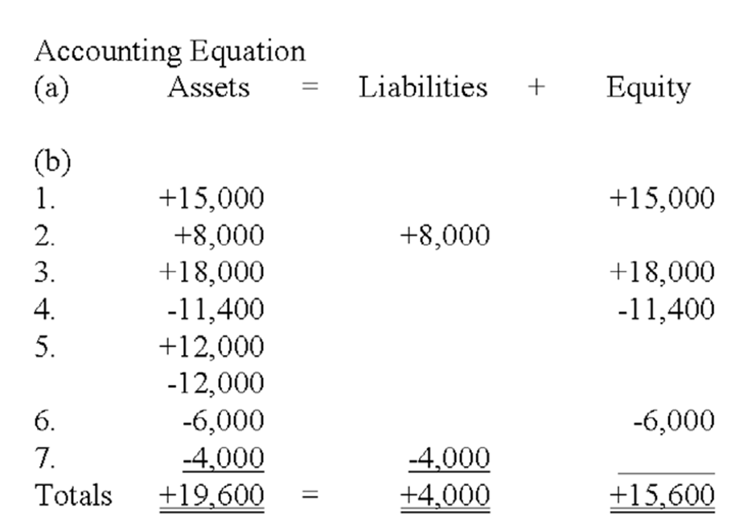

AACSB: Analytic
AICPA BB: Critical Thinking
AICPA FN: Measurement
AICPA FN: Reporting
Blooms: Apply
Difficulty: 2 Medium
Learning Objective: 01-03 Interpret information shown in an accounting equation.
Topic: Asset Source, Use, and Exchange Transactions

129. | Each of the following requirements is independent of the others.  a) Viking Corporation has liabilities of $85,000 and equity of $115,000. What is the amount of Viking's assets? _________________________________________________  b) Garibaldi Company has assets of $310,000 and liabilities of $95,000. What is the amount of Garibaldi's equity? ______________________________________________________  c) King Company has assets of $70,000 and liabilities of $25,000. What is the amount of King's claims? _____________________________________________________________  a) Assets = liabilities + equity = $85,000 + 115,000 = $200,000  b) Assets - liabilities = equity. Equity = $310,000 - 95,000 = $215,000  c) Assets = claims. Total amount of claims = $70,000

AACSB: Analytic
AICPA BB: Critical Thinking
AICPA FN: Measurement
AICPA FN: Reporting
Blooms: Apply
Difficulty: 2 Medium
Learning Objective: 01-02 Construct an accounting equation and show how business events affect the equation.
Topic: The Accounting Equation

130. | The following events occurred for Jarvis Company during 2012, its first year in operation:  1. issued stock to investors for $35,000 cash  2. borrowed $15,000 cash from the local bank  3. provided services to its customers and received $22,000 cash  4. paid expenses of $18,000  5. paid $12,000 cash for land  6. paid dividend of $2,000 to stockholders  7. repaid $2,000 of the loan listed in item 2  Required:  Show the effects of the above transactions on the accounting equation, below. Include dollar amounts of increases and decreases. The first is done for you. After entering all the events, calculate the total amounts of assets, liabilities, and equity at the end of the year.  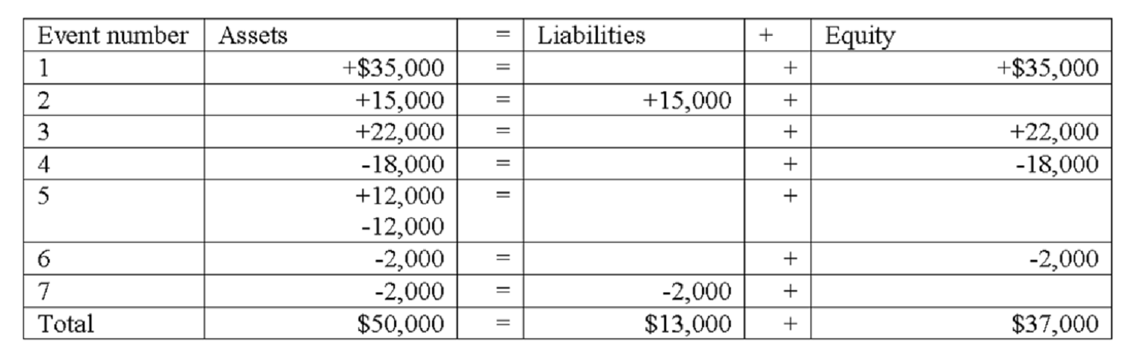

AACSB: Analytic
AICPA BB: Critical Thinking
AICPA FN: Measurement
Blooms: Apply
Difficulty: 2 Medium
Learning Objective: 01-02 Construct an accounting equation and show how business events affect the equation.
Topic: Elements of Financial Statements

131. | Ramon Company experienced the following events during 2012:  1. Acquired $50,000 cash by issuing common stock  2. Borrowed $15,000 cash from a creditor  3. Provided services to customers for $33,000 cash  4. Paid $27,000 cash for operating expenses  5. Paid a cash dividend of $1,500 to stockholders  6. Purchased land with cash, $25,000  Required:  a) Show how each of these events affects the accounting equation. Show amounts and increases or decreases, using + for increases and - for decreases and NA for no effect. The first event is done as an example.  b) Calculate the total amount of assets, liabilities, common stock, and retained earnings at the end of the period.  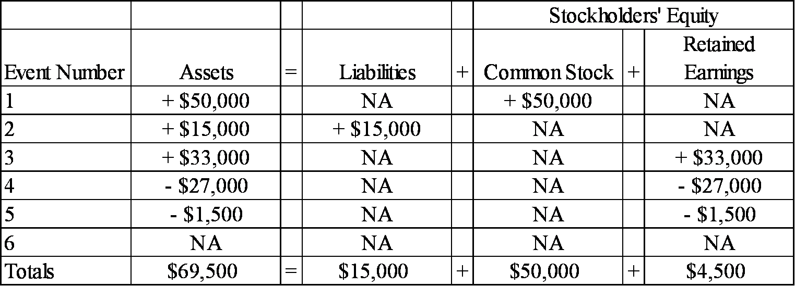

AACSB: Analytic
AICPA BB: Critical Thinking
AICPA FN: Measurement
Blooms: Apply
Difficulty: 2 Medium
Learning Objective: 01-03 Interpret information shown in an accounting equation.
Topic: Asset Source, Use, and Exchange Transactions

132. | At the beginning of 2012, Gratiot Company's accounting records had the general ledger accounts and balances shown in the table below. During 2012, the following transactions occurred:  1. received $95,000 cash for providing services to customers  2. paid salaries expense, $50,000  3. purchased land for $12,000 cash  4. paid $4,000 on note payable  5. paid operating expenses, $22,000  6. paid cash dividend, $2,500  Required:  a) Record the transactions in the appropriate general ledger accounts. Record the amounts of revenue, expense, and dividends in the retained earnings column. Provide appropriate titles for these accounts in the last column of the table.  b) What is the amount of total assets as of December 31, 2012?  c) What is the amount of total stockholders' equity as of December 31, 2012?  a)  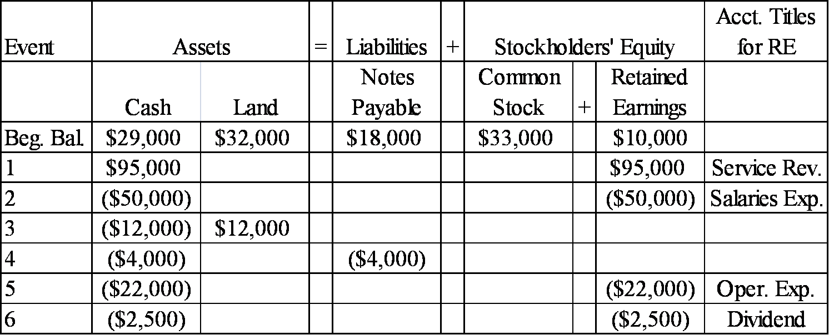  b) Total assets = $33,500 + $44,000 = $77,500  c) Total stockholders' equity = $33,000 + $30,500 = $63,500

AACSB: Analytic
AICPA BB: Critical Thinking
AICPA FN: Measurement
AICPA FN: Reporting
Blooms: Apply
Difficulty: 2 Medium
Learning Objective: 01-03 Interpret information shown in an accounting equation.
Topic: Asset Source, Use, and Exchange Transactions

133. | Jarvis Company experienced the following events during 2012 (all were cash events):  1. issued a note  2. purchased land  3. provided services to customers  4. repaid part of the note in event 1  5. paid operating expenses  6. paid a dividend to stockholders  7. issued common stock  Required:  Indicate how each of these events affects the accounting equation by writing the letter I for increase, the letter D for decrease, and NA for no effect under each of the components of the accounting equation. The first is done for you as an example.  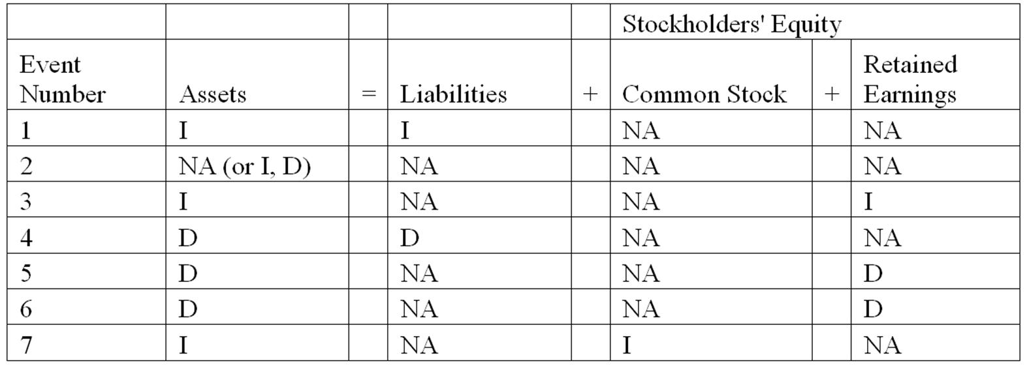

AACSB: Analytic
AICPA BB: Critical Thinking
AICPA FN: Measurement
AICPA FN: Reporting
Blooms: Understand
Difficulty: 2 Medium
Learning Objective: 01-03 Interpret information shown in an accounting equation.
Topic: Asset Source, Use, and Exchange Transactions

134. | Indicate how each of the following transactions affect assets by entering + for increase, - for decrease, or NA if total assets are not affected.  _______ 1) Issued stock to investors.  _______ 2) Borrowed cash from the bank.  _______ 3) Provided services for cash.  _______ 4) Purchased land for cash.  _______ 5) Paid operating expenses.  _______ 6) Paid cash dividend to the stockholders.  _______ 7) Repaid the bank loan.  1) +, 2) +, 3) +, 4) + - or NA, 5) -, 6) -, 7) -

AACSB: Analytic
AICPA BB: Critical Thinking
AICPA FN: Measurement
AICPA FN: Reporting
Blooms: Understand
Difficulty: 2 Medium
Learning Objective: 01-03 Interpret information shown in an accounting equation.
Topic: Asset Source, Use, and Exchange Transactions

135. | Classify each of the following events as an asset source (AS), asset use (AU), asset exchange (AX), or not applicable (NA).  _______ 1) Borrowed cash from the bank.  _______ 2) Issued stock for cash.  _______ 3) Invested cash in the common stock of another company.  _______ 4) Paid cash for operating expense.  _______ 5) Performed services and collected cash.  _______ 6) Purchased equipment for cash.  _______ 7) Repaid the bank loan with cash.  _______ 8) Dividends paid to the stockholders.  1) AS 2) AS 3) AX 4) AU 5) AS 6) AX 7) AU 8) AU

AACSB: Analytic
AICPA BB: Critical Thinking
AICPA FN: Measurement
Blooms: Understand
Difficulty: 2 Medium
Learning Objective: 01-04 Classify business events as asset source; use; or exchange transactions.
Topic: Asset Use Transactions
Topic: Source and Exchange Transactions

136. | Grayson Corporation reports the following cash transactions for the year ending December 31, 2012, its first year of operation:  1) issued common stock for $36,000  2) borrowed $20,000 from a local bank  3) purchased land for $24,000  4) provided services to clients for $28,000  5) paid operating expenses of $21,500  6) paid $2,500 cash dividends to stockholders  Required:  a) What are the total assets for Grayson Corporation at December 31, 2012?  b) Prepare an income statement for 2012.  a) Total assets equal $60,000 ($36,000 + 20,000 + 28,000 - 21,500 - 2,500)  b)  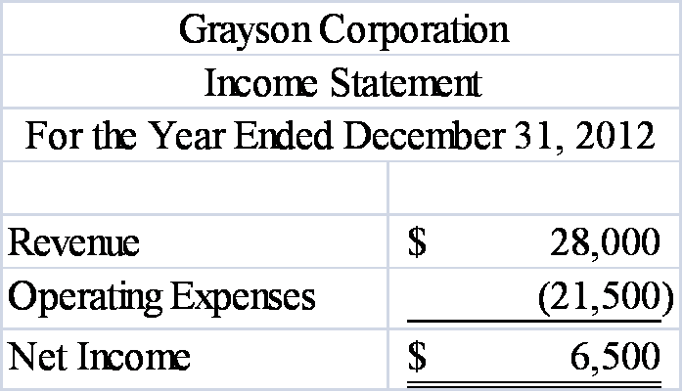

AACSB: Analytic
AICPA BB: Critical Thinking
AICPA FN: Measurement
AICPA FN: Reporting
Blooms: Apply
Difficulty: 2 Medium
Learning Objective: 01-05 Use general ledger account information to prepare four financial statements.
Topic: Income Statement

137. | Yang Company reported the following balance sheet for the end of 2012:  During 2013, Yang reported the following transactions:  • Repaid $8,000 to a local bank on a note payable  • Provided services to clients for $26,400 cash  • Paid operating expenses of $19,200  • Paid $3,500 cash dividends to stockholders  Required:  Prepare Yang Company's balance sheet as of December 31, 2013.  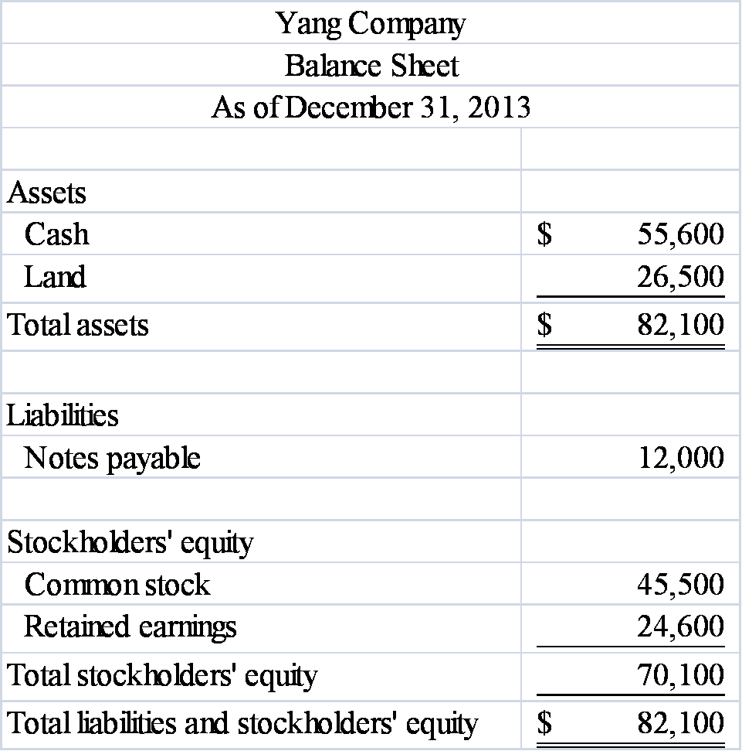  Feedback: Ending balances: Cash ($59,900 - $8,000 + $26,400 - $19,200 - $3,500); Land - No change; Notes payable ($20,000 - $8,000); Common stock - No change; Retained earnings ($20,900 + $26,400 - $19,200 - $3,500)

AACSB: Analytic
AICPA BB: Critical Thinking
AICPA FN: Measurement
AICPA FN: Reporting
Blooms: Apply
Difficulty: 2 Medium
Learning Objective: 01-05 Use general ledger account information to prepare four financial statements.
Topic: Balance Sheet

138. | Use the following information to prepare an income statement for Grandin Company for the period ending December 31, 2012. All transactions were for cash.  A) Received revenue from services provided to customers, $28,500.  B) Paid $19,000 cash for land.  C) Paid operating expenses, $19,400.  D) Paid dividends to stockholders, $3,200.  E) Issued $16,000 of common stock.  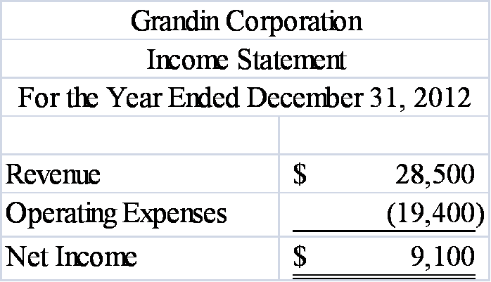  Feedback: Only revenue and expenses are reported on the income statement. Purchasing land, paying dividends, and issuing common stock do not affect the income statement.

AACSB: Analytic
AICPA BB: Critical Thinking
AICPA FN: Measurement
AICPA FN: Reporting
Blooms: Apply
Difficulty: 1 Easy
Learning Objective: 01-05 Use general ledger account information to prepare four financial statements.
Topic: Income Statement

139. | The following events are for Leisure Travel Services for the year 2013, the first year of operations. Assume that all transactions involve the receipt or payment of cash.  1) The business acquired $40,000 from stock issued to owners.  2) Creditors loaned the company $17,500.  3) The company provided services to its customers and received $55,400.  4) The company paid expenses amounting to $43,250.  5) The company purchased land for $29,000.  6) The company paid a dividend of $5,000 to its owners.  Required:  a) Show the effects of the above transactions on the accounting equation (use appropriate element and account headings). For those events that affect retained earnings, indicate in a separate column the appropriate temporary account.  b) Prepare an income statement and balance sheet for the year 2013.  a)  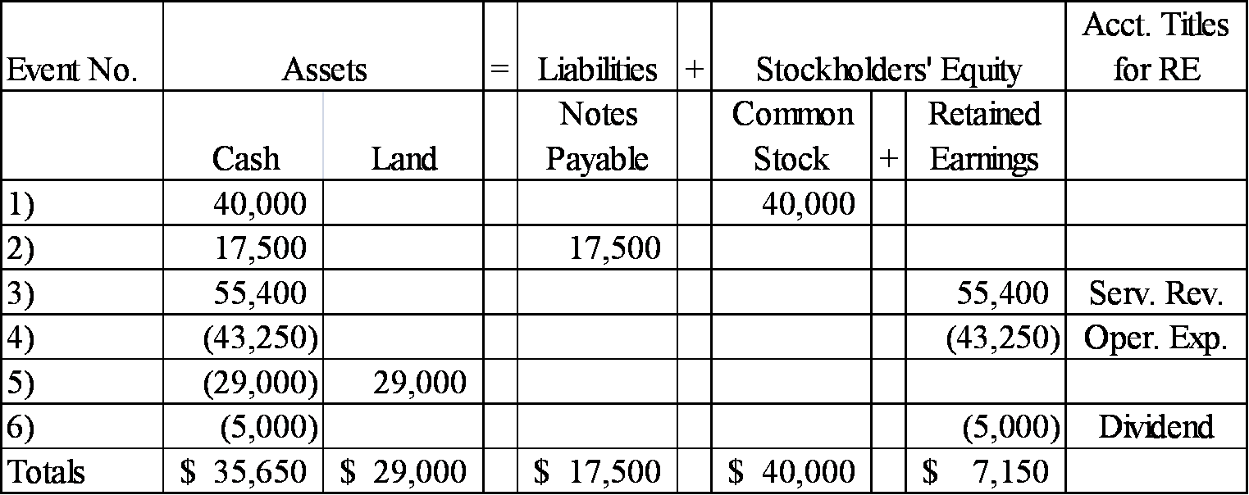  b)  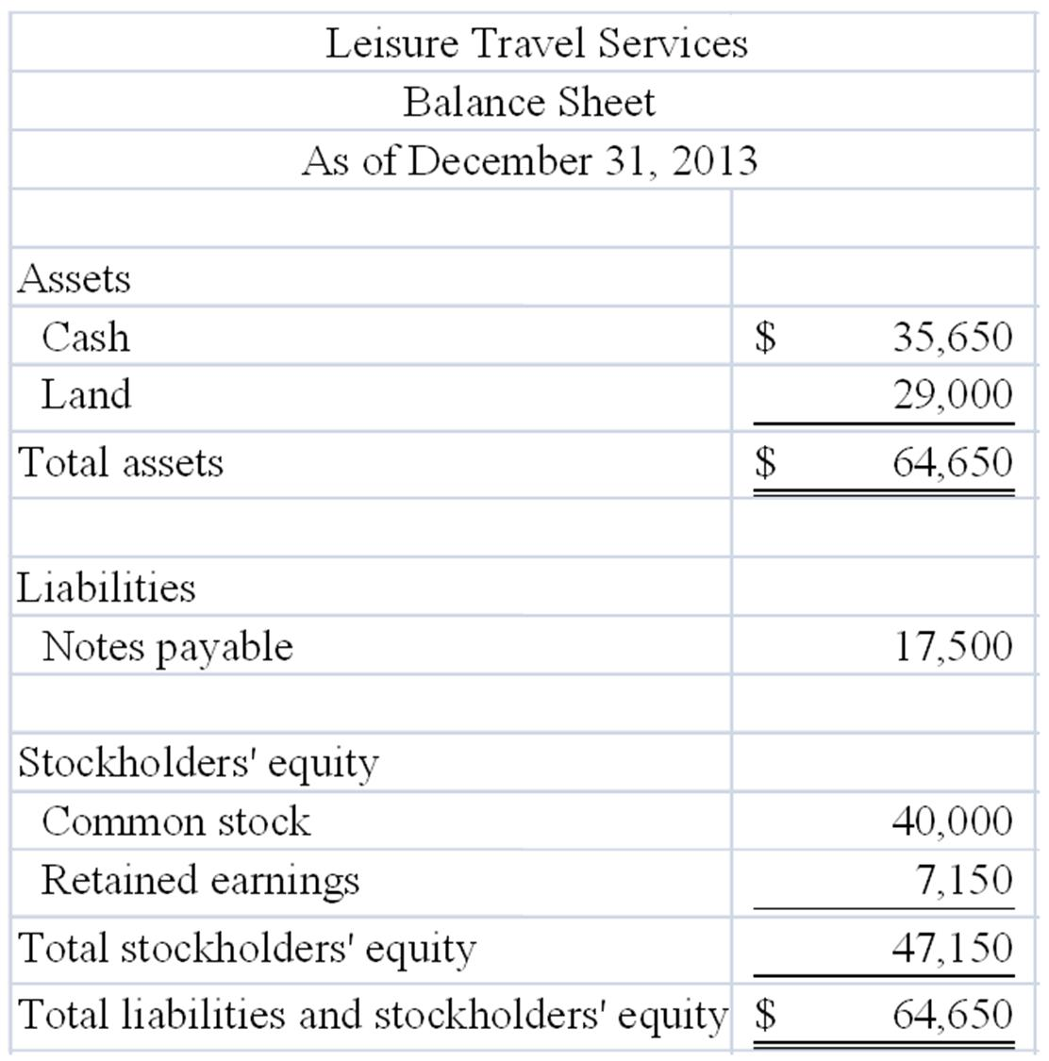  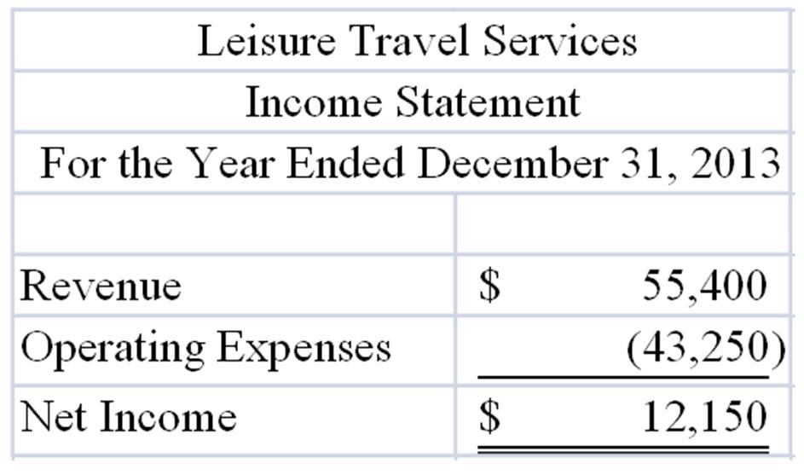

AACSB: Analytic
AICPA BB: Critical Thinking
AICPA FN: Measurement
AICPA FN: Reporting
Blooms: Analyze
Difficulty: 2 Medium
Learning Objective: 01-05 Use general ledger account information to prepare four financial statements.
Topic: Balance Sheet, Income Statement

140. | The following transactions apply to Warren Fitness Center for 2012.  1) Started the business by issuing $38,000 of common stock for cash.  2) Provided services to clients and received $28,500 cash.  3) Borrowed $7,500 from the bank.  4) Paid $6,500 for rent of equipment.  5) Purchased land for $12,000.  6) Paid $16,600 of salary expense.  7) Cash dividends of $4,500 were paid to the stockholders.  Required:  a) What are the total assets of the business at the end of 2012?  b) Prepare a Statement of Cash Flows for 2012.  a) $38,000 + $28,500 + $7,500 - $6,500 + $12,000 - $12,000 - $16,600 - $4,500 = $46,400  b)  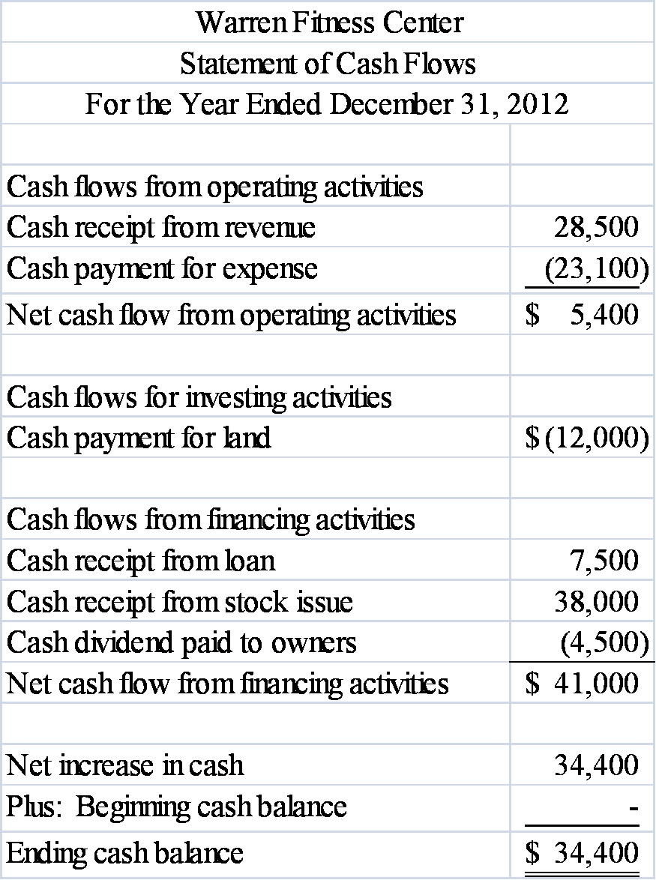

AACSB: Analytic
AICPA BB: Critical Thinking
AICPA FN: Measurement
AICPA FN: Reporting
Blooms: Analyze
Difficulty: 3 Hard
Learning Objective: 01-05 Use general ledger account information to prepare four financial statements.
Topic: Statement of Cash Flows

141. | Fill in the missing information by determining the amounts represented by letters a - d.  a) $9,700, b) $3,500, c) $3,500, d) $14,500

AACSB: Analytic
AICPA BB: Critical Thinking
AICPA FN: Measurement
AICPA FN: Reporting
Blooms: Analyze
Difficulty: 2 Medium
Learning Objective: 01-05 Use general ledger account information to prepare four financial statements.
Topic: Income Statement, Statement of Changes in Equity

142. | Fill in the blanks indicated by the alphabetic letters in the following financial statements. These financial statements were prepared for the company's first year in operation, and all transactions were for cash.  Solve for "l" first: l + 40,000 - 6,000 = 46,000; l = 12,000  Next, solve for "k": k - 10,000 + 46,000 = 50,000; k = 14,000  Next, solve for "j": 22,000 - j = 14,000; j = 8,000  Next, solve for "a": a = j; a = 8,000  Next, solve for "b": 22,000 - 8,000 = b; b = 14,000  Next, solve for "c": c = b; c = 14,000  Next, solve for "d": 0 + 14,000 - d = 8,000; d = 6,000 (can also be taken from statement of cash flows)  Next, solve for "e": 40,000 + 8,000 = 48,000  Next, solve for "f": f + 10,000 = 60,000; f = 50,000  Next, solve for "h": h = 8,000 (taken from statement of changes in equity)  Next, solve for "i": 40,000 + 8,000 = i; i = 48,000  Last, solve for "g": g + 48,000 = 60,000; g = 12,000

AACSB: Analytic
AICPA BB: Critical Thinking
AICPA FN: Measurement
AICPA FN: Reporting
Blooms: Analyze
Difficulty: 3 Hard
Learning Objective: 01-05 Use general ledger account information to prepare four financial statements.
Topic: Income Statement, Statement of Changes in Equity, Balance Sheet, Statement of Cash Flows

143. | The following transactions apply to the Grant Corporation for 2013, its first year in business.  1) Issued stock to investors, $24,000.  2) The company borrowed $21,000 cash from the bank.  3) Services were provided to customers and $24,000 cash was received.  4) The company loaned $5,000 to another company.  5) The company acquired land for $22,000.  6) The company paid $12,000 rent for the building where it does its business.  7) The company paid $1,600 for supplies that were used during the period.  8) The company sold the land acquired in item 5 for $22,000.  9) A dividend of $5,000 was made to the owners.  10) Repaid $10,000 of the loan described in item 2.  Required:  Prepare a statement of cash flows for 2013.  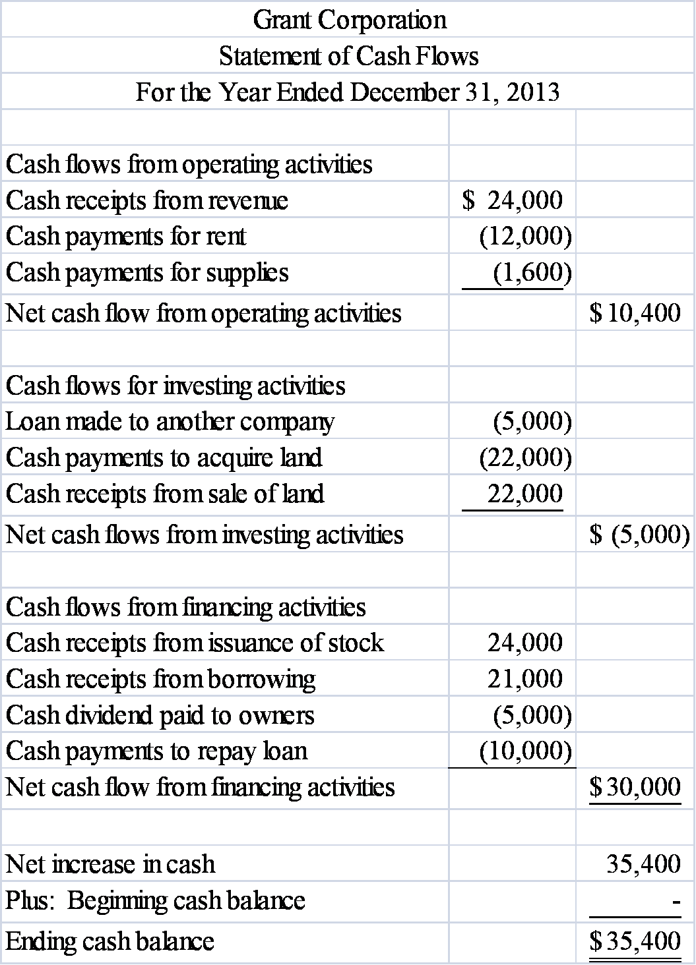

AACSB: Analytic
AICPA BB: Critical Thinking
AICPA FN: Measurement
AICPA FN: Reporting
Blooms: Analyze
Difficulty: 3 Hard
Learning Objective: 01-05 Use general ledger account information to prepare four financial statements.
Topic: Statement of Cash Flows

144. | Rosemont Company began operations on January 1, 2013, and on that date issued stock for $60,000 cash. In addition, Rosemont borrowed $50,000 cash from the local bank. The company provided services to its customers during 2013 and received $35,000. It purchased land for $70,000. During the year, it paid $10,000 cash for salaries and $9,000 cash for supplies that were used up in its operations. Stockholders were paid cash dividends of $8,000 during the year.  Required:  a) List the transactions from the information above (for example, issued common stock for $60,000) and indicate in which section of the statement of cash flows each transaction would be reported.  b) What would the amount be for net cash flows from operating activities?  c) What would be the amount of the total assets for the Rosemont Company at the end of 2013?  d) What would the end-of-year balance be for the retained earnings account?  e) What would the end-of-year balance be for the cash account?  a)  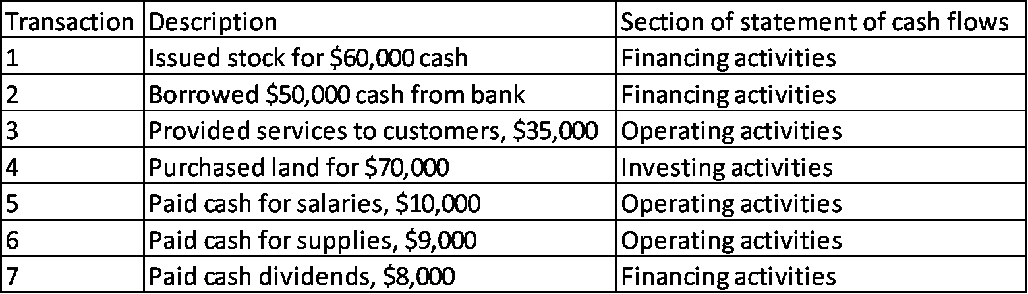  b) Net cash flows from operating activities = $16,000 ($35,000 - 10,000 - 9,000).  c) Total Assets = $118,000 (Cash = $48,000; Land = $70,000)  d) Retained earnings balance: $8,000 ($35,000 - 10,000 - 9,000 - 8,000).  e) Cash account balance: $48,000.

AACSB: Analytic
AICPA BB: Critical Thinking
AICPA FN: Measurement
AICPA FN: Reporting
Blooms: Analyze
Difficulty: 3 Hard
Learning Objective: 01-05 Use general ledger account information to prepare four financial statements.
Topic: Statement of Changes in Equity, Balance Sheet, Statement of Cash Flows

145. | The Ruiz Company began operations on January 1, 2013 and on that date issued $30,000 of common stock for cash. In addition, the company borrowed $20,000 from the bank. It provided services to its customers during 2013 and received $36,000 cash. During the year, it paid $40,000 cash for land, $10,000 for salaries, and $6,000 in cash dividends to the owners.  Required:  1) Write an accounting equation and record the effects of each transaction under the appropriate heading. (Use specific accounting titles below the statement elements)  2) Prepare an income statement and a balance sheet for the 2013 accounting period.  1)  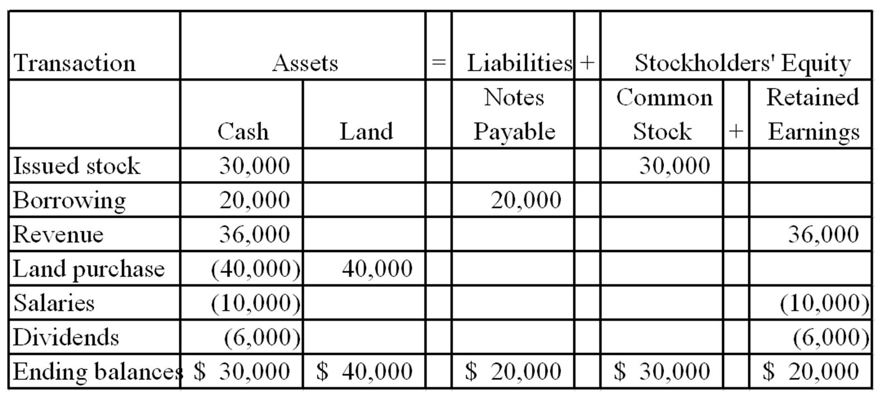  2)  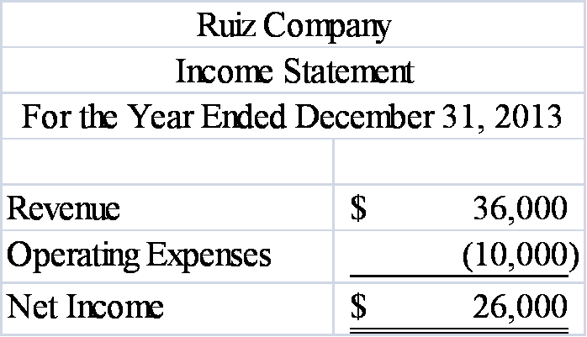

AACSB: Analytic
AICPA BB: Critical Thinking
AICPA FN: Measurement
AICPA FN: Reporting
Blooms: Analyze
Difficulty: 2 Medium
Learning Objective: 01-03 Interpret information shown in an accounting equation.
Learning Objective: 01-05 Use general ledger account information to prepare four financial statements.
Topic: Asset Source, Use, and Exchange Transactions
Topic: Income Statement

146. | Canton Company was formed in 2013 and experienced the following accounting events during the year:  1. issued common stock for $10,000 cash  2. earned cash revenue of $15,000  3. paid cash expenses of $13,000.  These were the only events that affected the company during the year.  Required:  a) Write the accounting equation and record the effects of each accounting event under the appropriate general ledger account heading.  b) Prepare an income statement for 2013 and a balance sheet as of December 31, 2013.  a) 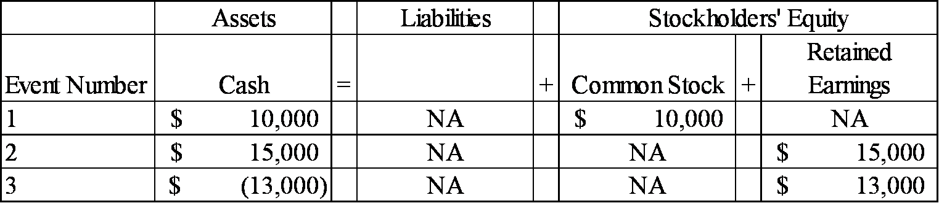  b)  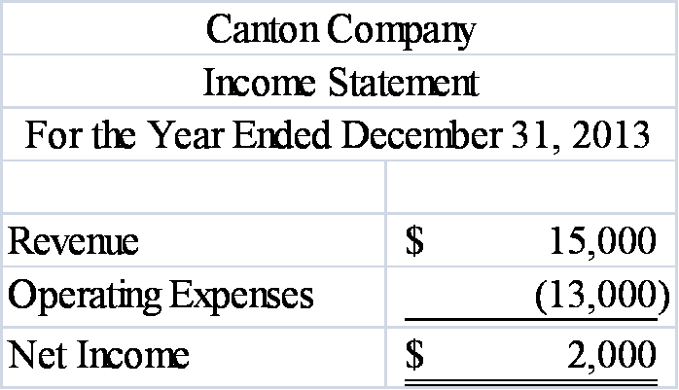  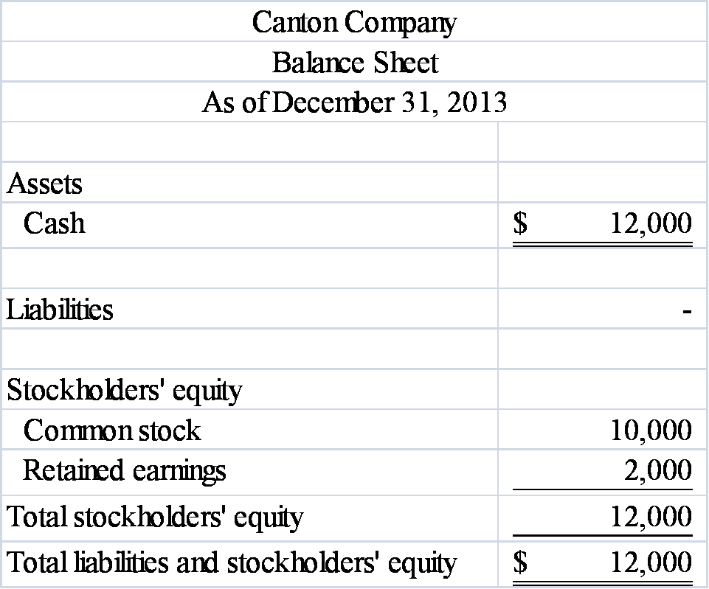

AACSB: Analytic
AICPA BB: Critical Thinking
AICPA FN: Measurement
AICPA FN: Reporting
Blooms: Analyze
Difficulty: 2 Medium
Learning Objective: 01-03 Interpret information shown in an accounting equation.
Learning Objective: 01-05 Use general ledger account information to prepare four financial statements.
Topic: Asset Source, Use, and Exchange Transactions
Topic: Income Statement, Balance Sheet

147. | Flagstone Company was founded on January 1, 2013. During 2013, the company experienced the following events:  1. earned cash revenue of $25,000  2. paid cash expenses of $20,500  3. issued common stock for $15,000 cash  4. paid cash dividend of $1,000 to owners.  Required:  a) Write an accounting equation and record effects of each accounting event under appropriate general ledger account headings, showing dollar amounts of increases and decreases and totals at the end of the year.  b) Prepare the 2013 income statement and balance sheet for Flagstone Company.  a) 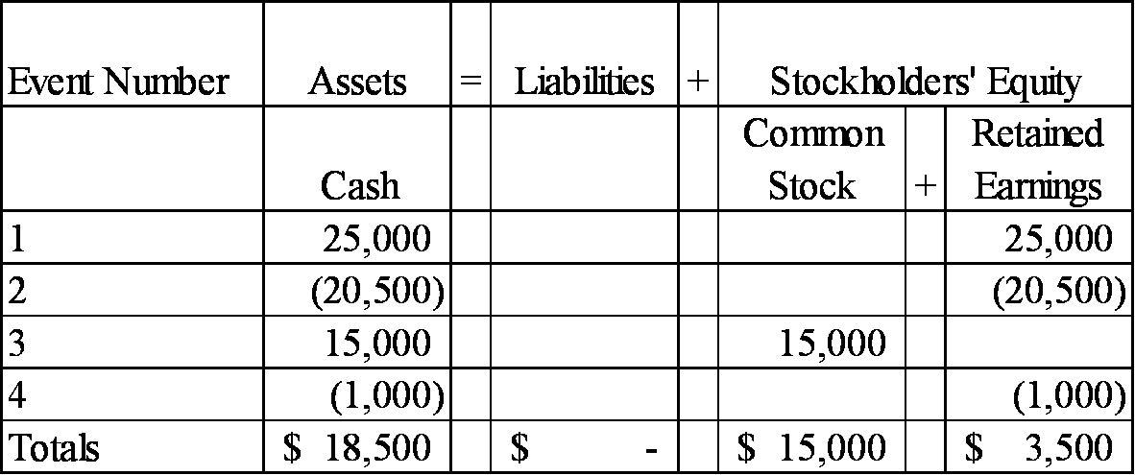  b)  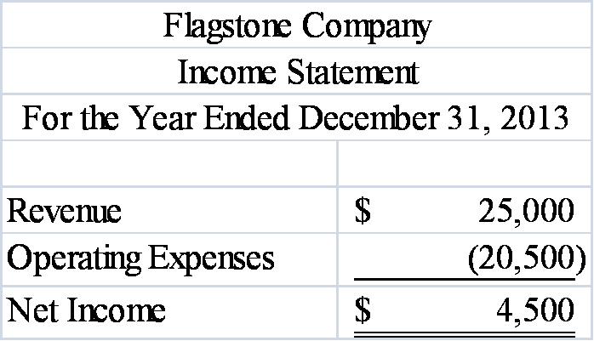  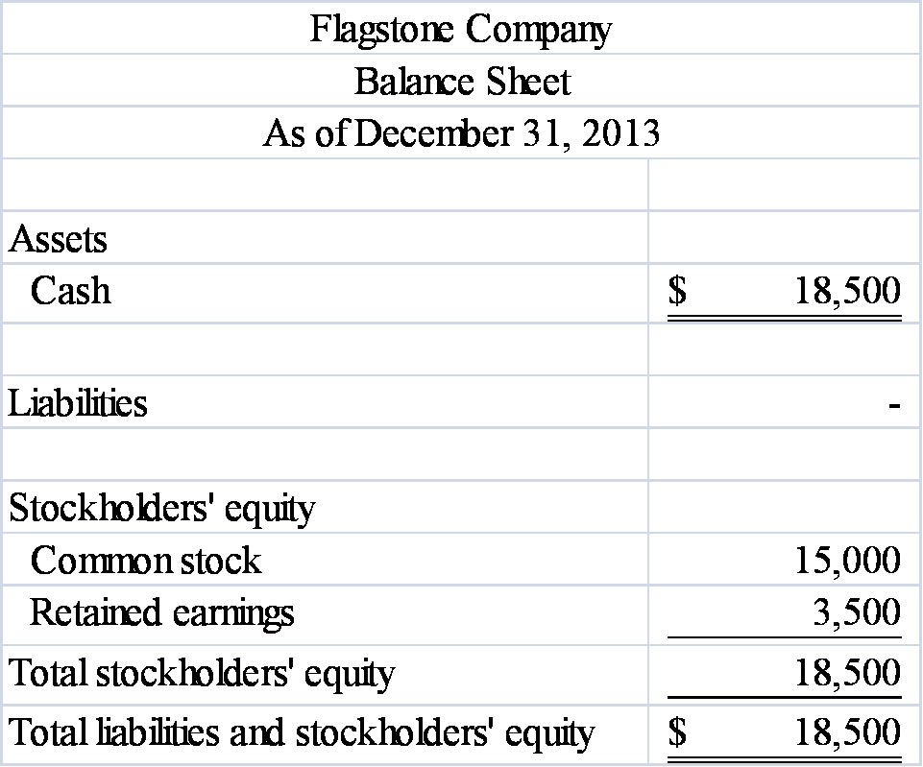

AACSB: Analytic
AICPA BB: Critical Thinking
AICPA FN: Measurement
AICPA FN: Reporting
Blooms: Analyze
Difficulty: 2 Medium
Learning Objective: 01-03 Interpret information shown in an accounting equation.
Learning Objective: 01-05 Use general ledger account information to prepare four financial statements.
Topic: Asset Source, Use, and Exchange Transactions
Topic: Income Statement, Balance Sheet

148. | During 2013, Saranac Company earned $12,000 of cash revenue and paid $8,200 of cash expenses and $600 in dividends to the company's owners. Enter each of these three events into the horizontal financial statements model, below. Indicate dollar amounts of increases and decreases. For cash flows, show whether they are operating activities (OA), investing activities (IA), or financing activities (FA).  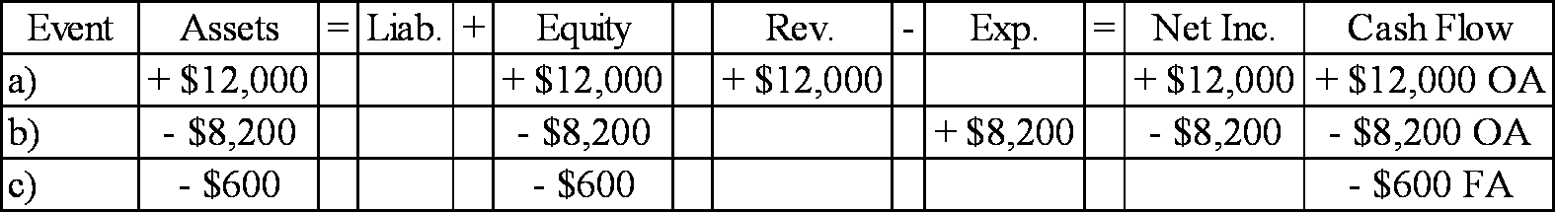

AACSB: Analytic
AICPA BB: Critical Thinking
AICPA FN: Measurement
AICPA FN: Reporting
Blooms: Understand
Difficulty: 2 Medium
Learning Objective: 01-03 Interpret information shown in an accounting equation.
Topic: Asset Source and Use Transactions

149. | During 2013, Wynona Company issued common stock to stockholders for $12,000, purchased land for $3,200 cash, and paid cash dividends of $1,000 to the company's owners. Enter each of these three events into the horizontal financial statements model, below. Indicate dollar amounts of increases and decreases. For cash flows, show whether they are operating activities (OA), investing activities (IA), or financing activities (FA).  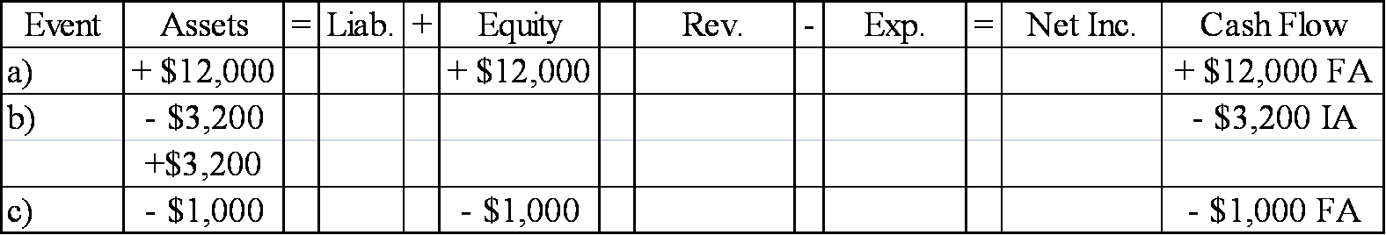

AACSB: Analytic
AICPA BB: Critical Thinking
AICPA FN: Measurement
AICPA FN: Reporting
Blooms: Apply
Difficulty: 2 Medium
Learning Objective: 01-03 Interpret information shown in an accounting equation.
Topic: Asset Source and Use Transactions

150. | During 2013, XYZ Company issued common stock to stockholders for $10,000; purchased land for $2,000 cash; provided services to customers for $8,000; paid cash operating expenses of $6,200; and paid cash dividends of $1,000 to the company's owners. Enter each of these events into the horizontal financial statements model, below. Indicate dollar amounts of increases and decreases. For cash flows, show whether they are operating activities (OA), investing activities (IA), or financing activities (FA).  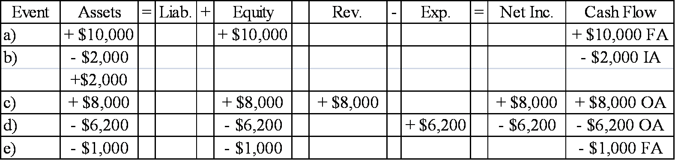

AACSB: Analytic
AICPA BB: Critical Thinking
AICPA FN: Measurement
AICPA FN: Reporting
Blooms: Apply
Difficulty: 2 Medium
Learning Objective: 01-07 Record business events using a horizontal financial statements model.
Topic: The Horizontal Financial Statements Model

